19 | Blood
Now that we’ve discussed the organs that pump and transport blood, let’s talk about blood itself. This chapter explores the structure and function of the tissue blood, including blood clotting and blood typing.
What Do You Think You Already Know?
Try to answer the following questions before proceeding to the next section. If you’re unsure of the correct answers, give it your best attempt based on previous courses, previous chapters, or just your general knowledge.
• How much blood does an average person have in his or her body?

• Why is blood red? What color is venous blood?

• Which blood type is the universal donor? Why?

Module 19.1: Overview of Blood
Module 19.1 in your text introduces you to the structure and function of blood. By the end of the module, you should be able to do the following:
1. Describe the major components of blood.
2. Describe the basic functions of blood.
3. Describe the overall composition of plasma, including the major types of plasma proteins, their functions, and where in the body they are produced.

Build Your Own Glossary
Following is a table listing key terms from Module 19.1. Before you read the module, use the glossary at the back of your book or look through the module to define the following terms.
Key Terms for Module 19.1
Term | Definition
Blood
Plasma
Formed elements
Hematocrit
Plasma proteins
Albumin
Outline It: Note Taking
Outline Module 19.1 using the note-taking technique you practiced in the introductory chapter (see Chapter 1). (The template is available in the study area of Mastering A&P.)
Identify It: Components of Blood
Identify and color-code each component of blood in Figure 19.1.
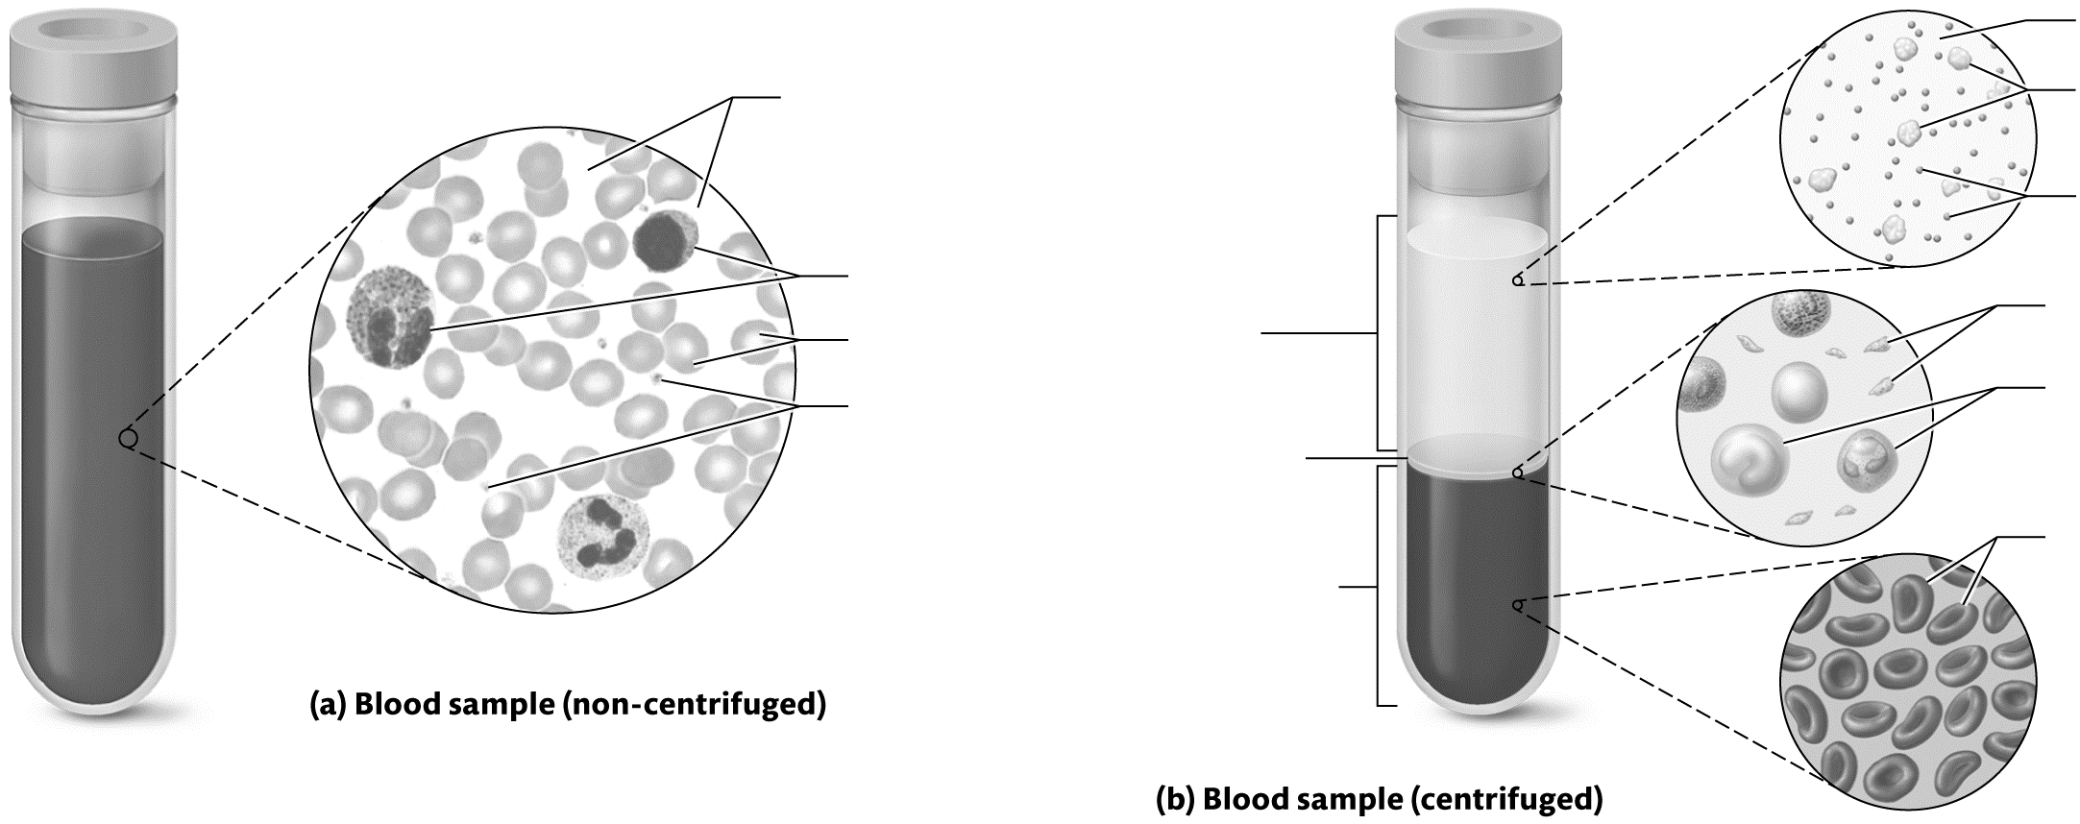
Figure 19.1 The layers of blood.

Key Concept: What are the main functions of blood?

Key Concept: What are the four types of plasma proteins, and what are their functions?

Module 19.2: Erythrocytes and Oxygen Transport
Now we look at the structure and development of the most common formed elements—the erythrocytes—and their role in the transport of oxygen through the body. When you finish this module, you should be able to do the following:
1. Describe the structure and functions of erythrocytes.
2. Discuss the structure and function of hemoglobin, as well as its breakdown products.
3. Explain the basic process of erythropoiesis and its regulation through erythropoietin.
4. Describe the causes and symptoms of anemia.
Build Your Own Glossary
Following is a table listing key terms from Module 19.2. Before you read the module, use the glossary at the back of your book or look through the module to define the following terms.
Key Terms for Module 19.2
Term | Definition
Erythrocyte
Hemoglobin
Hematopoiesis
Hematopoietic stem cell
Erythropoietin
Bilirubin
Anemia
Outline It: Note Taking
Outline Module 19.2 using the note-taking technique you practiced in the introductory chapter (see Chapter 1). (The template is available in the study area of Mastering A&P.)
Key Concept: How does the structure of an erythrocyte allow it to carry out its functions?

Complete It: Erythrocyte Structure
Fill in the blanks to complete the following paragraph that describes the structure and function of erythrocytes.
A mature erythrocyte consists of a plasma membrane surrounding cytosol filled with the protein ________________. This large protein consists of four polypeptide subunits: two ________________ chains and two ________________ chains. Each polypeptide chain has a ________________ group, which contains an ________________ ion. When this ion binds to oxygen, the overall protein is called ________________. Binding to oxygen causes the ion to become ________________, which is what gives blood its ________________ color. When this ion is not bound to oxygen, it is called ________________.
Key Concept: Why is blood red? What makes venous blood darker than arterial blood?

Key Concept: What is the stimulus for erythropoietin production and release? What action does erythropoietin trigger, and how does this return the variable to the homeostatic range?

Draw It: Hematopoiesis
Draw the stages that an erythrocyte goes through during the process of hematopoiesis. Under each drawing, name the cell type and explain what is happening in the cell at that stage.
Name:  Description: | Name:  Description: | Name:  Description:
Name:  Description: | Name:  Description: | Name:  Description:
Describe It: Processing of Old Erythrocytes
Describe the process by which old erythrocytes are processed and destroyed in Figure 19.2. In addition, label and color-code important structures involved in the process.
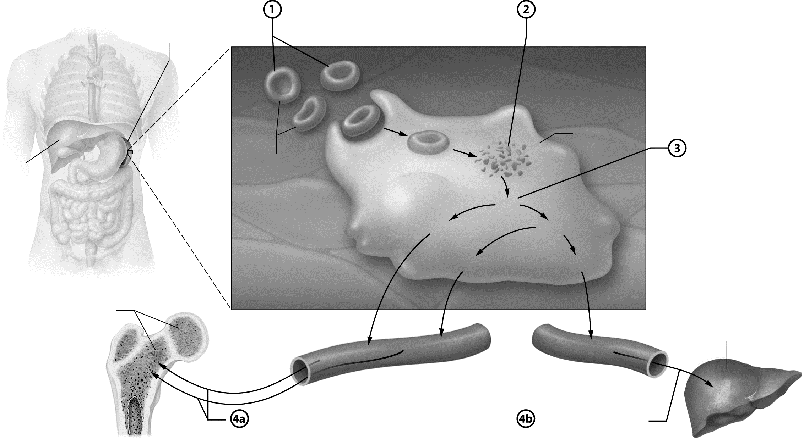
Figure 19.2 Erythrocyte death.
Key Concept: What are the three causes of anemia? How does each cause decrease the oxygen-carrying capacity of the blood?

Module 19.3: Leukocytes and Immune Function
The next major type of formed element we examine is the leukocyte. This module explores the different types of leukocytes, their development, and their functions. When you complete this module, you should be able to do the following:
1. Compare and contrast the relative prevalence and morphological features of the five types of leukocytes.
2. Describe functions for each of the five major types of leukocytes.
3. Discuss the difference in leukopoiesis of granulocytes and agranulocytes.
Build Your Own Glossary
Following is a table listing key terms from Module 19.3. Before you read the module, use the glossary at the back of your book or look through the module to define the following terms.
Key Terms of Module 19.3
Term | Definition
Leukocytes
Granulocyte
Agranulocyte
Neutrophil
Eosinophil
Basophil
Lymphocyte
Monocyte
Macrophage
Leukopoiesis
Outline It: Note Taking
Outline Module 19.3 using the note-taking technique you practiced in the introductory chapter (see Chapter 1). (The template is available in the study area of Mastering A&P.)
Key Concept: What are the key differences between erythrocytes and leukocytes?

Build Your Own Summary Table: Leukocytes
As you read Module 19.3, build your own summary table about the different types of leukocytes by filling in the information in the following table. In the “Appearance” column, draw the cell with colored pencils and point out the unique structural features of each type.

Summary of Leukocytes
Leukocyte | Appearance | Functions
Granulocytes
Neutrophils
Eosinophils
Granulocytes (continued)
Basophils
Agranulocytes
Lymphocytes
Monocytes
Key Concept: How do lymphocytes differ from all other cells in terms of their development in the bone marrow?

Module 19.4: Platelets
Module 19.4 in your text explores the final type of formed element: the platelet. At the end of this module, you should be able to do the following:
1. Explain how platelets differ structurally from the other formed elements of blood.
2. Discuss the role of the megakaryocyte in the formation of platelets.
Build Your Own Glossary
Following is a table listing key terms from Module 19.4. Before you read the module, use the glossary at the back of your book or look through the module to define the terms.

Key Terms of Module 19.4
Term | Definition
Platelets
Megakaryocyte
Outline It: Note Taking
Outline Module 19.4 using the note-taking technique you practiced in the introductory chapter (see Chapter 1). (The template is available in the study area of Mastering A&P.)
Key Concept: Are platelets cells? Explain your answer.

Describe It: Platelet Formation
Describe the process by which platelets are formed in Figure 19.3. In addition, label and color-code important structures involved in the process.
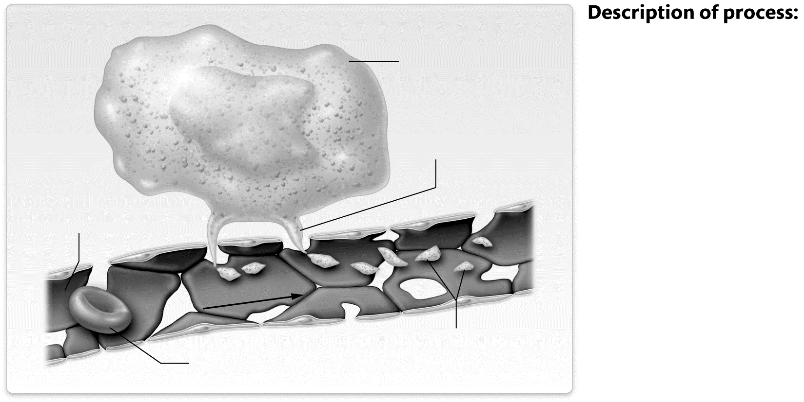

Figure 19.3 Platelet formation.
Module 19.5: Hemostasis
This module examines how blood loss from an injured vessel is minimized by a process called hemostasis. At the end of this module, you should be able to do the following:
1. Distinguish between the terms hemostasis and coagulation.
2. Describe the process of hemostasis, including the vascular phase, the formation of the platelet plug, and the formation of fibrin.
3. Explain the differences between the intrinsic and extrinsic clotting cascades.
4. Describe the role of calcium ions and vitamin K in blood clotting.
5. Explain how the positive feedback loops in the platelet and coagulation phases promote hemostasis.
6. Discuss the process of thrombolysis.
Build Your Own Glossary
Following is a table listing key terms from Module 19.5. Before you read the module, use the glossary at the back of your book or look through the module to define the following terms.
Key Terms of Module 19.5
Term | Definition
Hemostasis
Blood clot
Platelet plug
Coagulation
Coagulation cascade
Thrombin
Fibrin
Clot retraction
Fibrinolysis
Plasmin
Anticoagulant
Thrombosis
Outline It: Note Taking
Outline Module 19.5 using the note-taking technique you practiced in the introductory chapter (see Chapter 1). (The template is available in the study area of Mastering A&P.)
Key Concept: What is hemostasis? What are the five steps of hemostasis?

Key Concept: How and why does vascular spasm occur?

Describe It: Platelet Plug Formation
Describe the process by which platelet plug formation occurs in Figure 19.4. In addition, label and color-code important structures involved in the process.
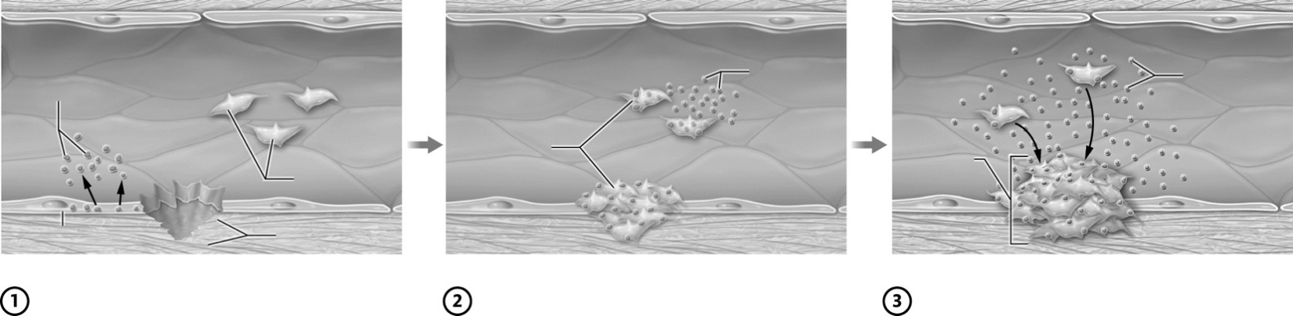

Figure 19.4 Hemostasis: Platelet plug formation.
Describe It: The Coagulation Cascade
Describe the process by which coagulation takes place in the intrinsic/contact activation pathway, extrinsic/tissue factor pathway, and common pathway in Figure 19.5. In addition, label and color-code important structures involved in the process.
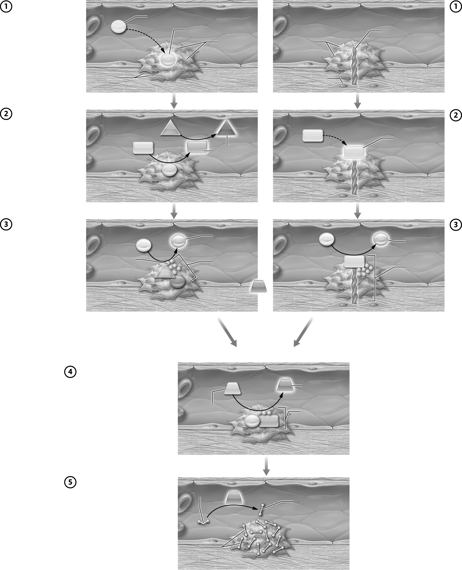

Figure 19.5 Hemostasis: Coagulation cascade.
Key Concept: What are the fundamental differences between the intrinsic and extrinsic pathways?

Key Concept: What is the overall purpose of coagulation?

Complete It: Clot Retraction and Thrombolysis
Fill in the blanks to complete the following paragraphs that describe clot retraction and fibrinolysis.
At the end of the coagulation cascade when ________________ threads “glue” the platelet plug together, the ________________ and ________________ fibers in the platelets contract. This action, called ________________ ________________, brings the edges of the vessel closer together. It also squeezes ________________ out of the clot, which contains plasma without ________________ ________________.
When the wounded vessel has healed, the clot is removed by the process of ________________. The first step of this process is to break down ________________ by the process of ________________. It begins when endothelial cells release ________________ ________________ ________________, which catalyzes the conversion of plasminogen to the active enzyme ________________. This enzyme then degrades ________________, which causes the clot to dissolve.
Key Concept: It is obviously important to clot a broken blood vessel. Why is it equally important to eventually break down that clot?

Key Concept: What is an anticoagulant? Why is it important to regulate positive feedback loops like coagulation?


Mix It Up: Bring It Back by Building Your Own Summary Table of Leukocytes
Let’s Mix It Up by building your own summary table of the different types of leukocytes. In the “Appearance” column, take advantage of the dual coding technique by drawing the cell with colored pencils and labeling its unique structural features.
Summary of Leukocytes
Leukocyte | Appearance | Functions
Granulocytes
Neutrophils
Eosinophils
Basophils

Leukocyte | Appearance | Functions
Agranulocytes
Lymphocytes
Monocytes

Module 19.6: Blood Typing and Matching
Now we look at the glycoproteins on the surface of cells, called antigens, which give rise to different blood types. By the end of the module, you should be able to do the following:
1. Explain the role of surface antigens on erythrocytes in determining blood groups.
2. List the type of antigen and the type of antibodies present in each ABO and Rh blood type.
3. Explain the differences between the development of anti-Rh antibodies and the development of anti-A
and anti-B antibodies.
4. Predict which blood types are compatible, and explain what happens when the incorrect ABO or Rh blood type is transfused.
5. Explain why blood type O– is the universal donor and type AB+ is the universal recipient.
Build Your Own Glossary
Following is a table listing key terms from Module 19.6. Before you read the module, use the glossary at the back of your book or look through the module to define the following terms.
Key Terms for Module 19.6
Term | Definition
Blood transfusion
Recipient
Donor
Antigen
Blood groups
ABO blood group
Rh blood group
Antibody
Universal donor
Universal recipient
Outline It: Note Taking
Outline Module 19.6 using the note-taking technique you practiced in the introductory chapter (see Chapter 1). (The template is available in the study area of Mastering A&P.)
Key Concept: What are antigens? What are the key antigens on erythrocytes?

Draw It: Blood Types
Draw each cell and its antigens indicated here by the blood type. Then, list the antibodies this blood type
will have in the blood (assume previous exposure to the Rh antigen).
Type A+  Antibodies: | Type B−  Antibodies: | Type O−  Antibodies:
Type AB−  Antibodies: | Type O+  Antibodies: | Type AB+  Antibodies:
Key Concept: What happens when antibodies bind their specific antigens?

Practice It: Blood Donation
Following are people who want to donate blood. Determine to which blood types they could safely donate. Explain in each case why the person could or could not donate to the recipient. Assume each recipient has been exposed to the Rh antigen and so has anti-Rh antibodies.
1. Donor Jane, blood type: B+
• Recipient 1: O+

• Recipient 2: AB–

• Recipient 3: AB+

2. Donor Jerome, blood type: O+
• Recipient 1: B+

• Recipient 2: AB−

• Recipient 3: A−

3. Donor Ngoc, blood type: A−
• Recipient 1: O−

• Recipient 2: B−

• Recipient 3: AB−

Key Concept: When considering blood donation, do we consider the antigens on the donor’s erythrocytes, the antibodies in the donor’s blood, or both? Explain.


What Do You Know Now?
Let’s now revisit the questions you answered at the beginning of this chapter. How have your answers changed now that you’ve worked through the material?
• How much blood does an average person have in his or her body?

• Why is blood red? What color is venous blood?

• Which blood type is the universal donor? Why?

Next Steps
You’ve just actively read your chapter, so now it’s time to start your Bring It Back practice sessions. What types of Bring It Back practice will you use to study blood?
__________________________________________________________________________________________
__________________________________________________________________________________________
Which resources in MasteringA&P and your textbook have you used so far in your Bring It Back practice? Are there any that you haven’t tried? If so, why not?
__________________________________________________________________________________________
__________________________________________________________________________________________
You likely have your first exam coming up soon. Based on your exam performance last semester, how will you adjust your studying the week before the exam?
________________________________________________________________________________________________
________________________________________________________________________________

We’ll see you in the next chapter!

