18 | The Cardiovascular System II: The Blood Vessels
We now turn to the next part of the cardiovascular system with the organs that transport blood to and from the heart: blood vessels. This chapter explores the structure and function of blood vessels and the anatomy of the arteries and veins of the body.
What Do You Think You Already Know?
Try to answer the following questions before proceeding to the next section. If you’re unsure of the correct answers, give it your best attempt based on previous courses, previous chapters, or just your general knowledge.
• What effect does the sympathetic nervous system have on blood pressure? Why?

• What are systole and diastole?

• Why can a person lose consciousness when placed in a choke hold?

Module 18.1: Overview of Arteries and Veins
Module 18.1 in your text introduces you to the structure and function of arteries and veins. By the end of the module, you should be able to do the following:
1. Compare and contrast the structures of arteries and veins, and of arterioles and venules.
2. Define vascular anastomosis, and explain the significance of anastomoses.

Build Your Own Glossary
Following is a table listing key terms from Module 18.1. Before you read the module, use the glossary at the back of your book or look through the module to define the following terms.

Key Terms for Module 18.1
Term | Definition
Artery
Capillary
Vein
Tunica intima
Tunica media
Tunica externa
Venous valve
Vascular anastomosis
Outline It: Note Taking
Outline Module 18.1 using the note-taking technique you practiced in the introductory chapter (see Chapter 1). (The template is available in the study area of Mastering A&P.)

Identify It: Layers of the Blood Vessel Wall
Identify and color-code each component of the blood vessel wall in Figure 18.1. Then, list the main function(s) of each tunic (layer).

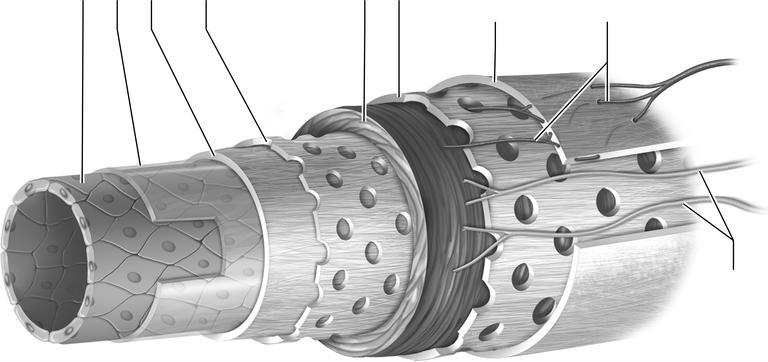

Figure 18.1 The tunics (layers) of the blood vessel wall.
Key Concept: Why is it important that a vessel be able to stretch? Which structures allow a vessel to stretch? What prevents it from overstretching?

Build Your Own Summary Table: Properties of Blood Vessels
As you read Module 18.1, build your own summary table about the different types of blood vessels by filling in the information in the following table. You can use text Table 18.1 on page 674 for reference, but the descriptions should be in your own words so that they make sense to you.
Properties of Blood Vessels and Blood Distribution
 | Elastic Artery | Muscular Artery | Arteriole | Venule | Vein
Structure | 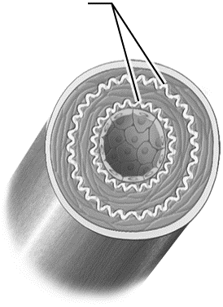 | 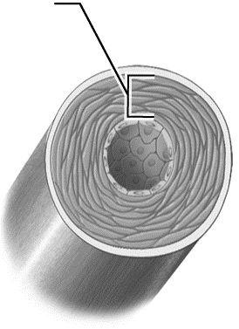 | 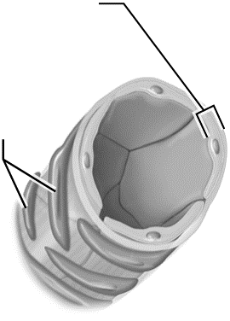 | 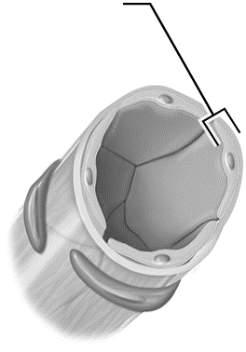 | 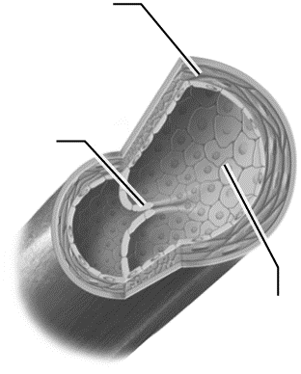
Description
Diameter
Functions
Key Concept: Why is a greater percentage of blood found in veins? Why is this important?

Module 18.2: Physiology of Blood Flow
Now we look at some of the fundamental principles of blood flow, or hemodynamics. When you finish this module, you should be able to do the following:
1. Describe the factors that influence blood flow, blood pressure, and peripheral resistance.
2. Explain the relationships between vessel diameter, cross-sectional area, blood pressure, and blood velocity.
3. Explain how blood pressure varies in different parts of the systemic and pulmonary circuits.
4. Describe how blood pressure changes in the arteries, capillaries, and veins.
5. Explain how mean arterial pressure is calculated.
6. Describe the mechanisms that assist in the return of venous blood to the heart.
Build Your Own Glossary
Following is a table listing key terms from Module 18.2. Before you read the module, use the glossary at the back of your book or look through the module to define the following terms.
Key Terms for Module 18.2
Term | Definition
Blood pressure
Blood flow
Peripheral resistance
Viscosity
Vessel compliance
Mean arterial pressure
Systolic pressure
Diastolic pressure
Pulse pressure

Outline It: Note Taking
Outline Module 18.2 using the note-taking technique you practiced in the introductory chapter (see Chapter 1). (The template is available in the study area of Mastering A&P.)

Key Concept: How does the heart drive blood through the blood vessels?

Complete It: Blood Flow
Fill in the blanks to complete the following paragraphs that describe properties of blood flow.
________________ ________________ is the outward force the blood exerts on the wall of the ________________ ________________. The magnitude of this gradient is one factor that determines ________________ ________________, which is the ________________ of blood that flows per minute. In general, this value matches the ________________ ________________ of about 5–6 liters/min. The second factor that determines blood flow is ________________, which is any ________________ to blood flow. Generally, as resistance increases, blood flow ________________.
The velocity with which blood flows is largely determined by the ________________ ________________ ________________ of the blood vessel. As this area increases, the velocity of blood flow ________________.

Predict It: Factors That Influence Blood Pressure
Predict whether blood pressure will increase or decrease given each of the following conditions. Justify each of your responses.
• A person does hot yoga and forgets to drink any water, becoming dehydrated.

• A patient is given a drug that causes vasoconstriction.

• The blood vessels contain numerous large plaques throughout the systemic circuit.

• A person meditates, lowering her heart rate.

Key Concept: What three factors determine blood pressure? How does each factor influence blood pressure?

Build Your Own Summary Table: Pressures in the Systemic Circuit
As you read Module 18.2, build your own summary table about the blood pressure in different parts of the systemic circuit by filling in the information in the following table.

Blood Pressure in Different Parts of the Systemic Circuit
Vessel | Pressure Range | Reason for Pressure Value
Arteries during systole
Arteries during diastole
Arterioles
Capillaries: arteriolar end
Capillaries: venular end
Venules
Veins

Key Concept: Why does venous blood need assistance in returning to the heart? What mechanisms are in place to assist in venous return?

Module 18.3: Maintenance of Blood Pressure
Blood pressure must be within a certain range to maintain life, but it must also be able to adjust to the changing demands of the body. This module explores how blood pressure is maintained and modified to ensure the needs of the body are met at all times. When you complete this module, you should be able to do the following:
1. Describe the role of arterioles in regulating tissue blood flow and systemic arterial blood pressure.
2. Describe the local, hormonal, and neural factors that affect and regulate blood pressure.
3. Explain the main effects and importance of the baroreceptor reflex.
4. Explain how the respiratory and cardiovascular systems maintain blood flow to tissues via the chemoreceptor reflex.
5. Describe common causes of and common treatments for hypertension.

Build Your Own Glossary
Following is a table listing key terms from Module 18.3. Before you read the module, use the glossary at the back of your book or look through the module to define the following terms.
Key Terms of Module 18.3
Term | Definition
Carotid and aortic sinuses
Baroreceptor reflex
Valsalva maneuver
Peripheral chemoreceptor
Hypertension
Hypotension

Outline It: Note Taking
Outline Module 18.3 using the note-taking technique you practiced in the introductory chapter (see Chapter 1). (The template is available in the study area of Mastering A&P.)

Key Concept: Which body systems are responsible for short-term maintenance of blood pressure? Which factors do these systems regulate?

Describe It: Effects of the Autonomic Nervous System on Blood Pressure
Describe the effects of the sympathetic and parasympathetic nervous systems in Figure 18.2. In addition, draw in the ECG change (tachycardia or bradycardia) and the arrows on the blood vessels to indicate vasoconstriction or vasodilation.

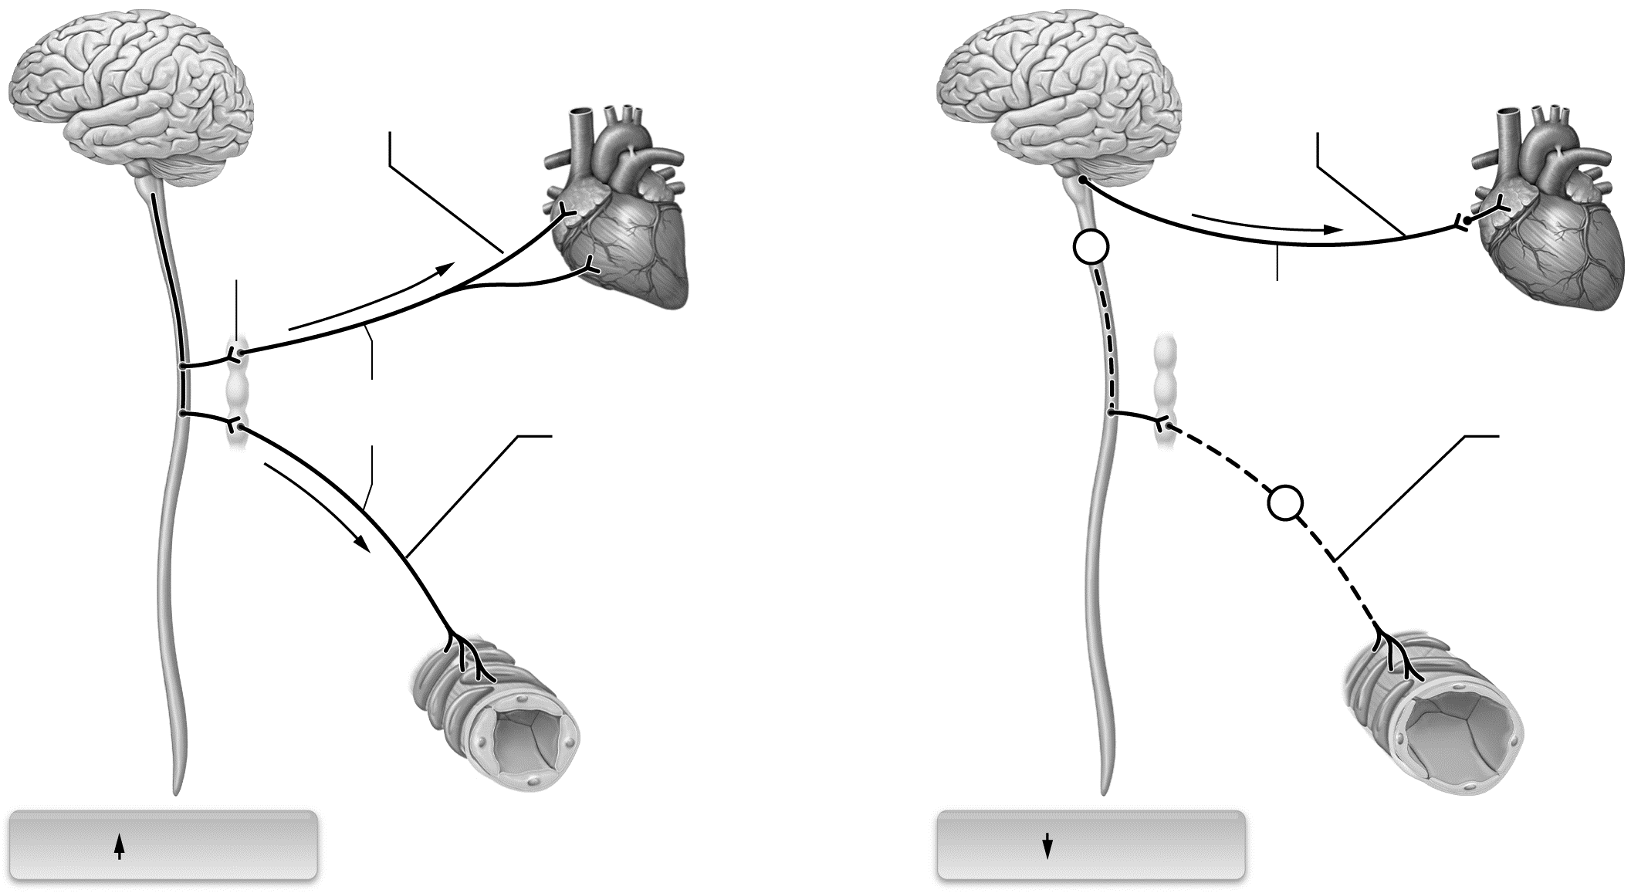

Figure 18.2 Effects of the ANS on blood pressure.

Key Concept: Why may someone temporarily lose consciousness when held in a choke hold?

Describe It: Effects of the Autonomic Nervous System on Blood Pressure
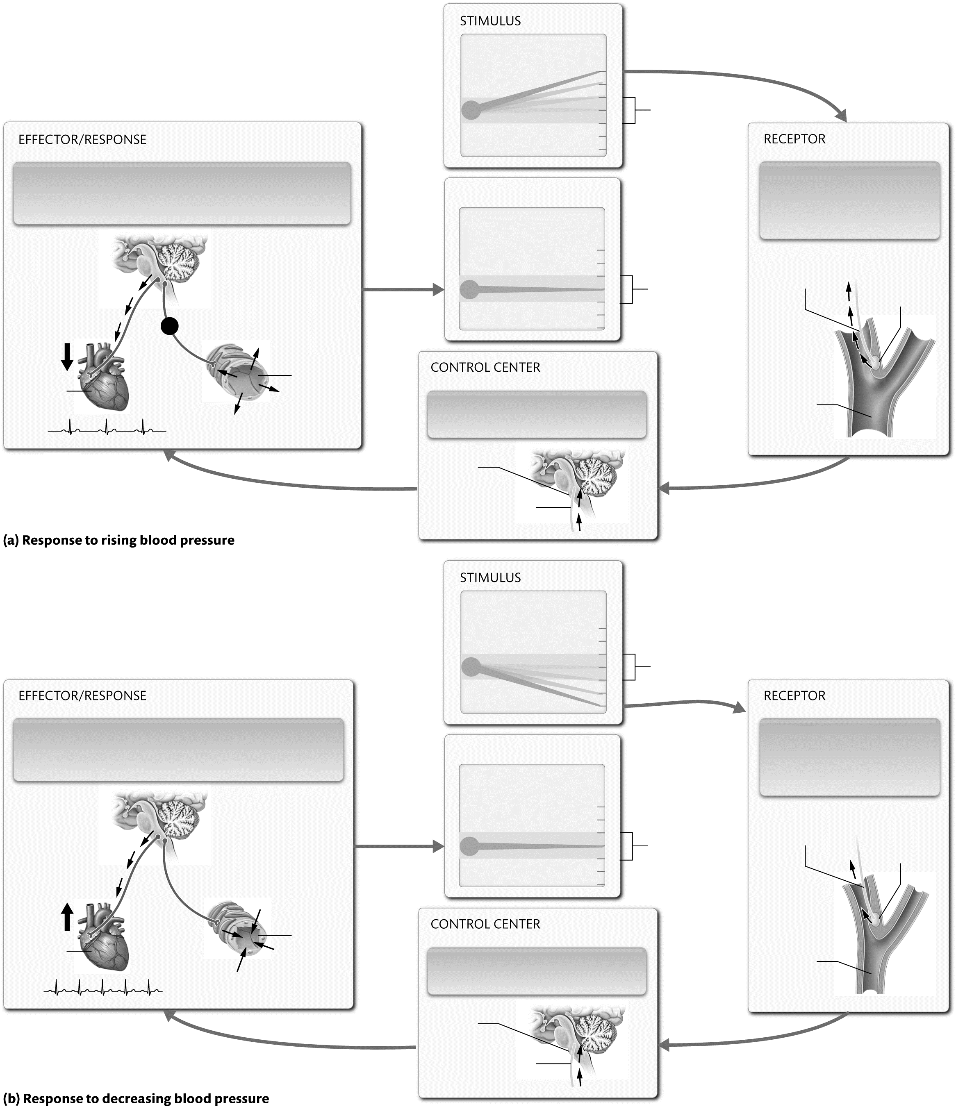
Describe the steps of the baroreceptor reflex feedback loops in Figure 18.3. In addition, label and color-code all relevant structures of the processes.

Figure 18.3 Regulation of blood pressure by the baroreceptor reflex.

Figure 18.3 (continued)

Key Concept: What is hypertension, and why is it dangerous? Why is hypotension also dangerous?

Module 18.4: Capillaries and Tissue Perfusion
Module 18.4 in your text explores the ways in which materials are exchanged in capillary beds. At the end of this module, you should be able to do the following:
1. Describe the different types of capillaries, and explain how their structure relates to their function.
2. Explain the roles of diffusion, filtration, and osmosis in capillary exchange.
3. Describe how autoregulation controls blood flow to tissues.

Build Your Own Glossary
Following is a table listing key terms from Module 18.4. Before you read the module, use the glossary at the back of your bookor look through the module to define the following terms.
Key Terms of Module 18.4
Term | Definition
Tissue perfusion
Capillary exchange
Continuous capillary
Fenestrated capillary
Sinusoid
Autoregulation
Myogenic mechanism

Outline It: Note Taking
Outline Module 18.4 using the note-taking technique you practiced in the introductory chapter (see Chapter 1). (The template is available in the study area of Mastering A&P.)
Key Concept: Why is tissue perfusion tightly regulated?

Identify It: Capillary Structure and Function
Identify and color-code each component of the capillary in part (a) of Figure 18.4. Then, describe the ways in which substances cross capillary walls in part (b).
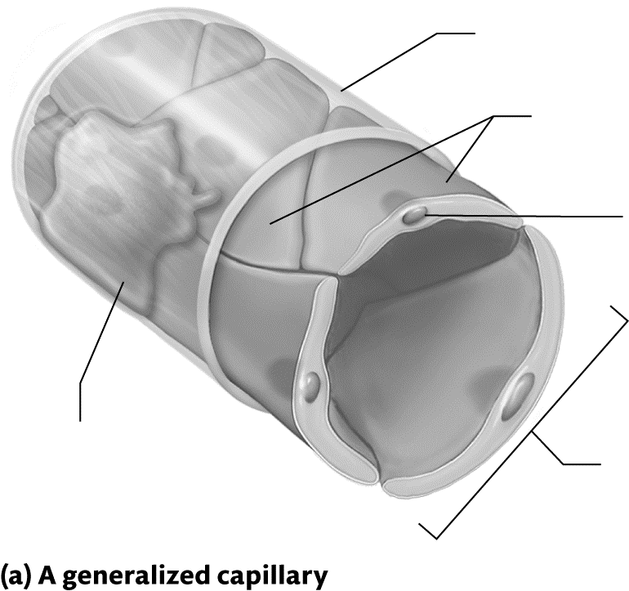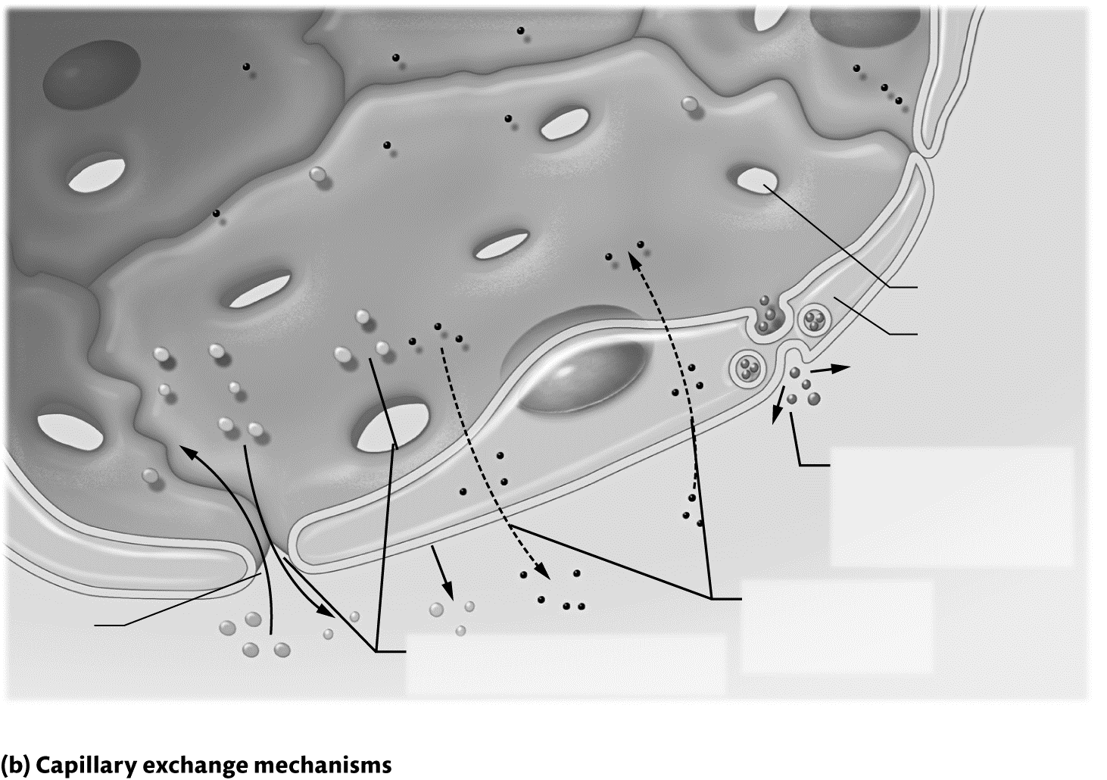

Figure 18.4 Structure and function of a capillary.
Identify It: Types of Capillaries
Identify each of the following statements as being properties of continuous, fenestrated, or sinusoidal capillaries.
• Located in the skin, muscle tissue, and most nervous and connective tissue ____________
• Have irregular basal laminae with very large pores; discontinuous sheets of endothelium ____________
• Endothelial cells joined by many tight junctions ____________
• Located in the kidneys, endocrine glands, and small intestine ____________
• Extremely leaky, allow large substances to cross the capillary walls ____________
• Contain fenestrations in their endothelial cells ____________
• Least leaky, allow a narrow range of substances to cross the capillary wall ____________

Key Concept: How does the myogenic mechanism regulate local tissue perfusion?

Key Concept: A cell is actively metabolizing glucose and producing carbon dioxide and consuming oxygen at a high rate. What effect will this have on local arterioles?

Complete It: Tissue Perfusion in Special Circuits
Fill in the blanks to complete the following paragraphs that describe tissue perfusion in different circuits.
Perfusion to the tissues of the heart ________________ ________________ during systole and ________________ ________________ during diastole. Perfusion to the heart increases dramatically during strenuous activity due to a low level of ________________ ________________ in the interstitial fluid, which triggers _________________ _______________.
Blood flow to the brain is maintained nearly constantly at ________________ ________________; however, perfusion to areas of the brain varies with ________________ ________________.
The increase in blood flow to skeletal muscle during exercise is called ________________ ________________. When exercise begins, the ________________ ________________ arterioles dilate, which triggers the ________________ ________________ to dilate, which finally triggers the ________________ ________________ ________________ to dilate.
Perfusion to the skin is regulated by the ________________ ________________ ________________ as part of the body’s ________________ ________________ physiology.

Module 18.5: Capillary Pressures and Water Movement
This module examines the pressures that drive water movement across capillaries. At the end of this module, you should be able to do the following:
1. Describe hydrostatic pressure and colloid osmotic pressure.
2. Explain how net filtration pressure across the capillary wall determines movement of fluid across that wall.
3. Explain how changes in hydrostatic and colloid osmotic pressure may cause edema.
Build Your Own Glossary
Following is a table listing key terms from Module 18.5. Before you read the module, use the glossary at the back of your book or look through the module to define the following terms.
Key Terms of Module 18.5
Term | Definition
Hydrostatic pressure
Filtration
Osmotic pressure
Colloid osmotic pressure
Net filtration pressure
Edema

Outline It: Note Taking
Outline Module 18.5 using the note-taking technique you practiced in the introductory chapter (see Chapter 1). (The template is available in the study area of Mastering A&P.)

Key Concept: What is hydrostatic pressure? In which direction does hydrostatic pressure push fluid in a capillary bed?

Key Concept: What is osmotic pressure? In which direction does osmotic pressure push or pull fluid in a capillary bed?

Draw It: Hydrostatic and Osmotic Pressure Gradients
Draw a blood vessel diagram similar to that in Figure 18.13 in your text, with a capillary connected by an arteriole and a venule. Write in the normal hydrostatic and colloid osmotic pressures and indicate with arrows whether each end will have net filtration or net absorption.

Calculate It: Net Filtration Pressure
Calculate the net filtration pressure for each of the following sets of values, and determine if there will be net filtration or net absorption.
1. Example 1:  • Arteriolar end HP: 45 mm Hg  • Venular end HP: 15 mm Hg  • OP (at both ends): 19 mm Hg | 2. Example 1:  • Arteriolar end HP: 25 mm Hg  • Venular end HP: 15 mm Hg  • OP (at both ends): 22 mm Hg
Module 18.6: Anatomy of the Systemic Arteries
Module 18.6 in your text explores the anatomy of the systemic arteries. By the end of the module, you should be able to do the following:
1. Describe the patterns of arterial blood flow for the head and neck, the thoracic cavity, the abdominopelvic cavity, and the upper and lower limbs.
2. Identify major arteries of the systemic circuit.
3. Identify the major pulse points.
Build Your Own Glossary
Following is a table listing key terms from Module 18.6. Before you read the module, use the glossary at the back of your book or look through the module to define the following terms.
Key Terms for Module 18.6
Term | Definition
Aorta
Common carotid artery
Cerebral arterial circle
Celiac trunk
Common iliac artery
Subclavian artery
Pulse
Pulse point

Outline It: Note Taking
Outline Module 18.6 using the note-taking technique you practiced in the introductory chapter (see Chapter 1). (The template is available in the study area of Mastering A&P.)

Key Concept: What are the four divisions of the aorta? How does the last division of the aorta end, and what structures do these vessels supply?

Identify It: Arteries of the Head and Neck
Identify and color-code each of the arteries of the head and neck in Figure 18.5. Then, list the main structures that each artery supplies.

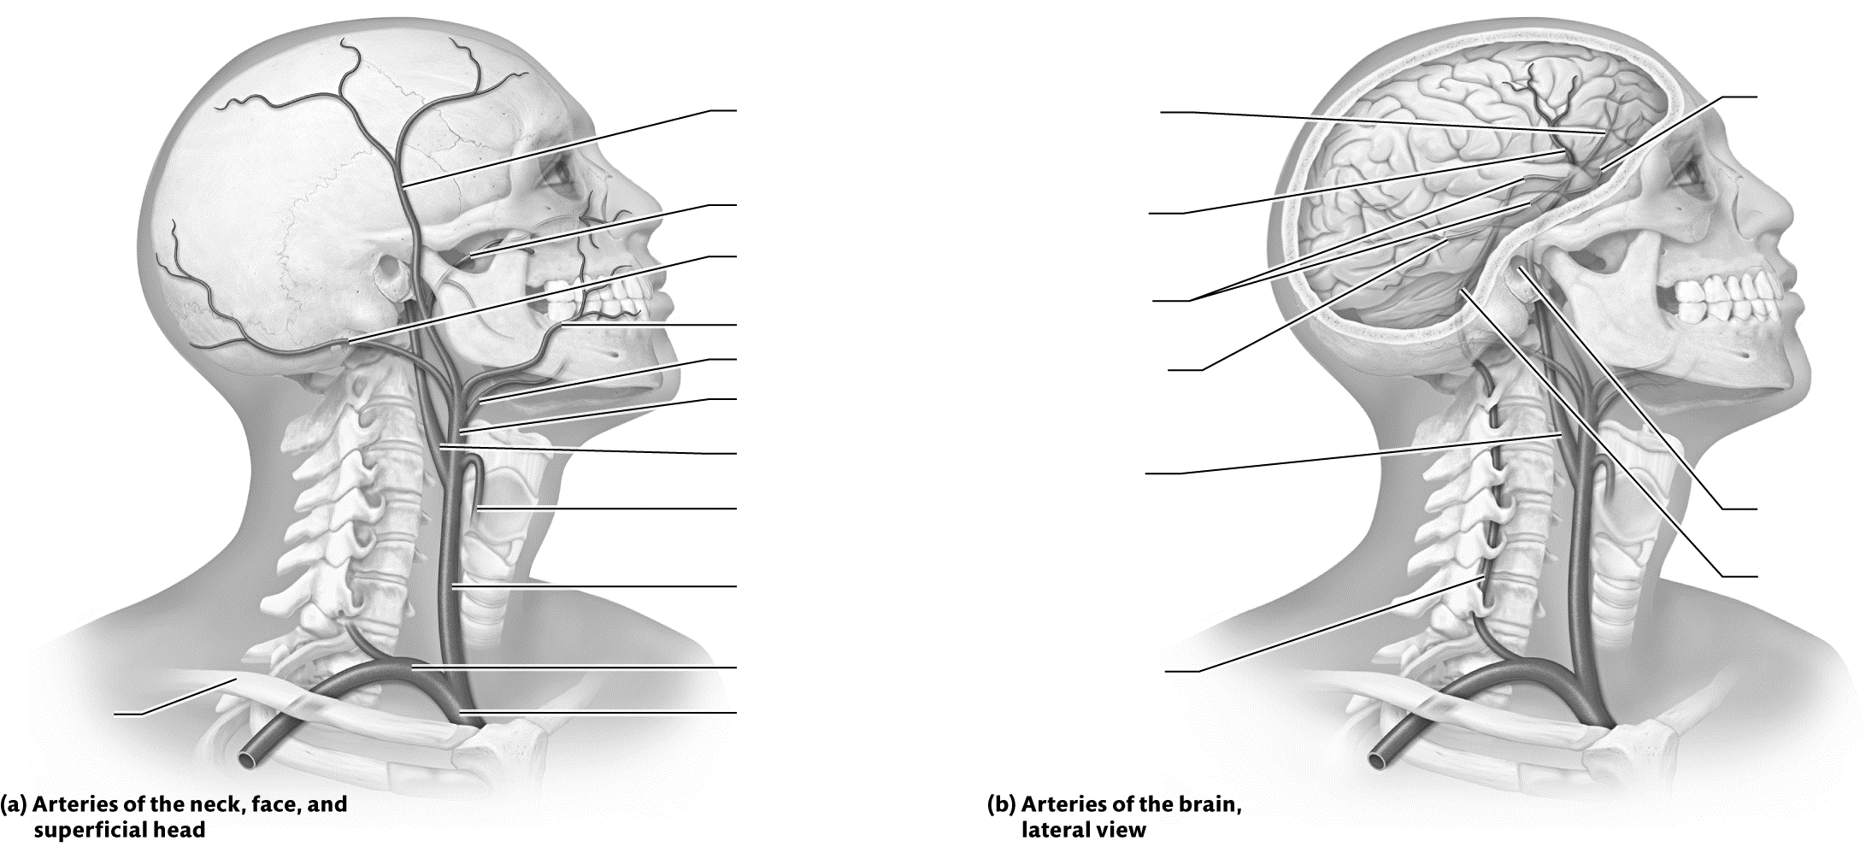

Figure 18.5 Arteries of the head and neck.

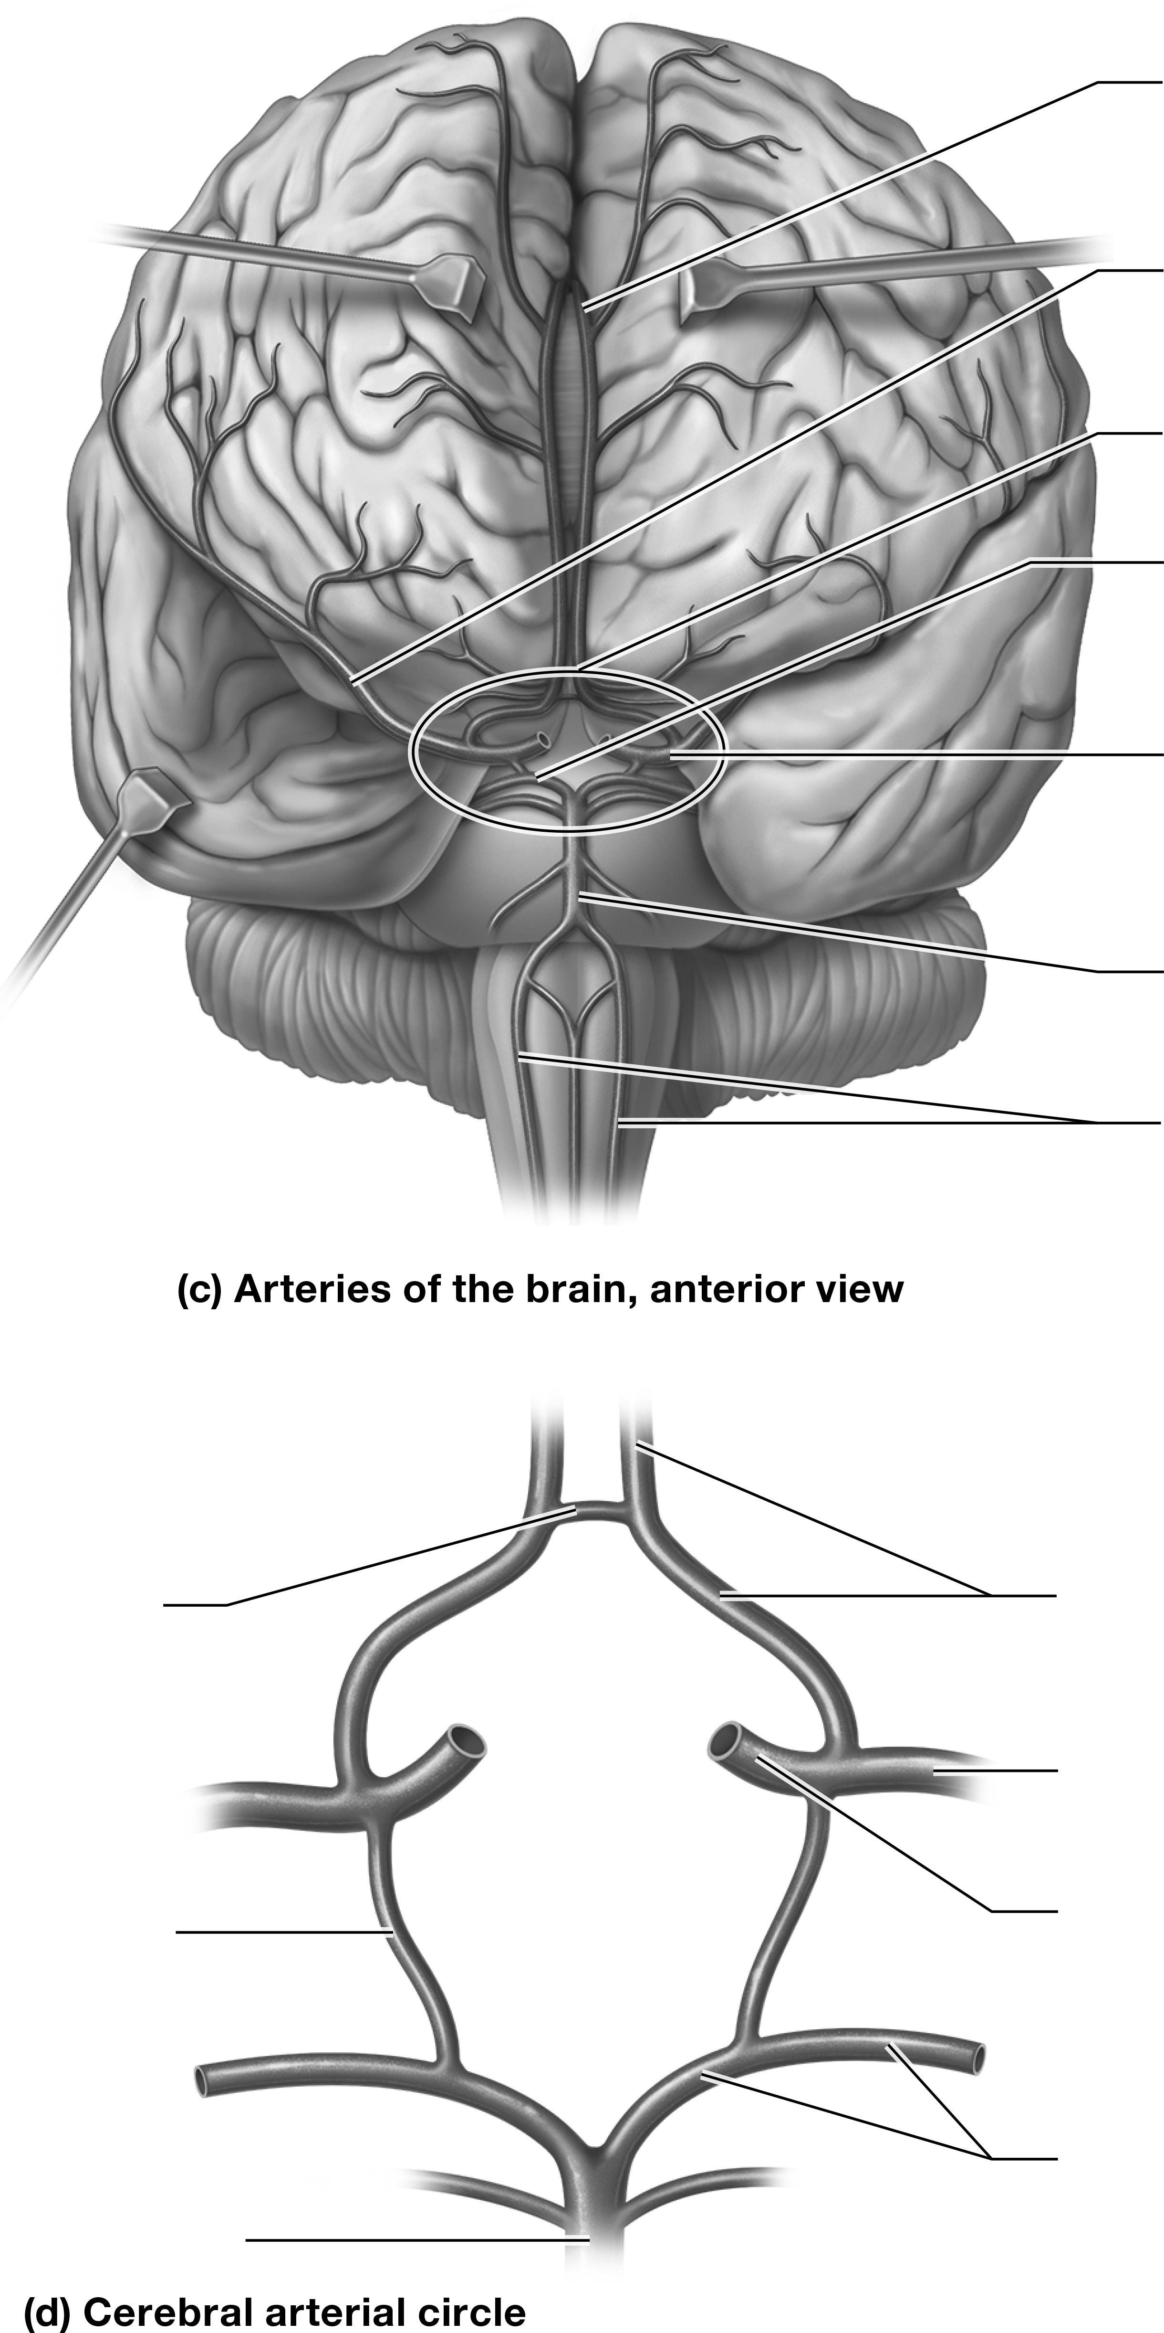

Figure 18.5 (continued).
Key Concept: What is the importance of the cerebral arterial circle?

Identify It: Arteries of the Abdomen
Identify and color-code each of the arteries of the abdomen in Figure 18.6. Then, list the main structures that each artery supplies.

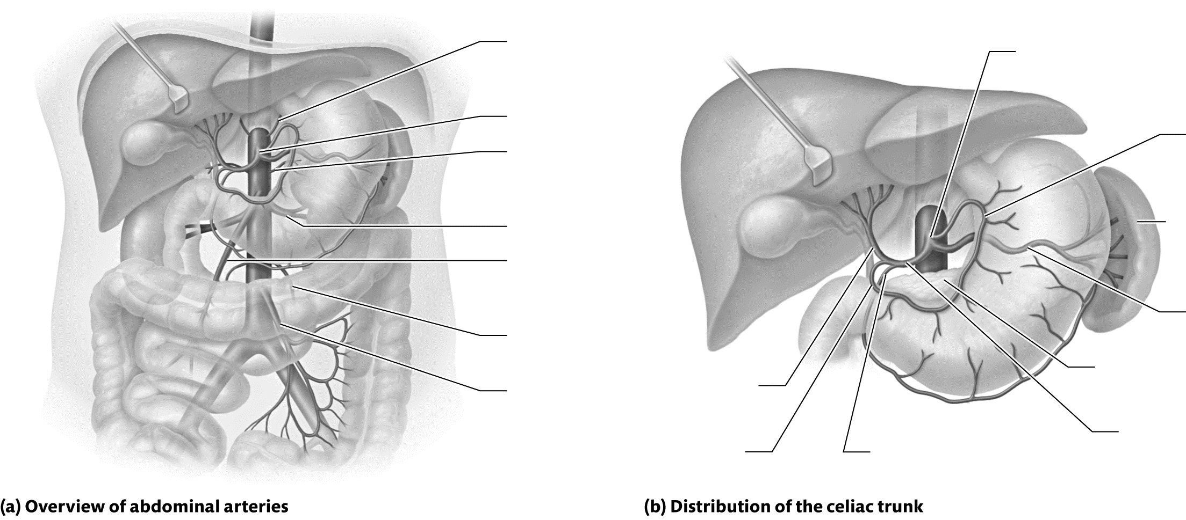

Figure 18.6 Arteries of the abdomen.
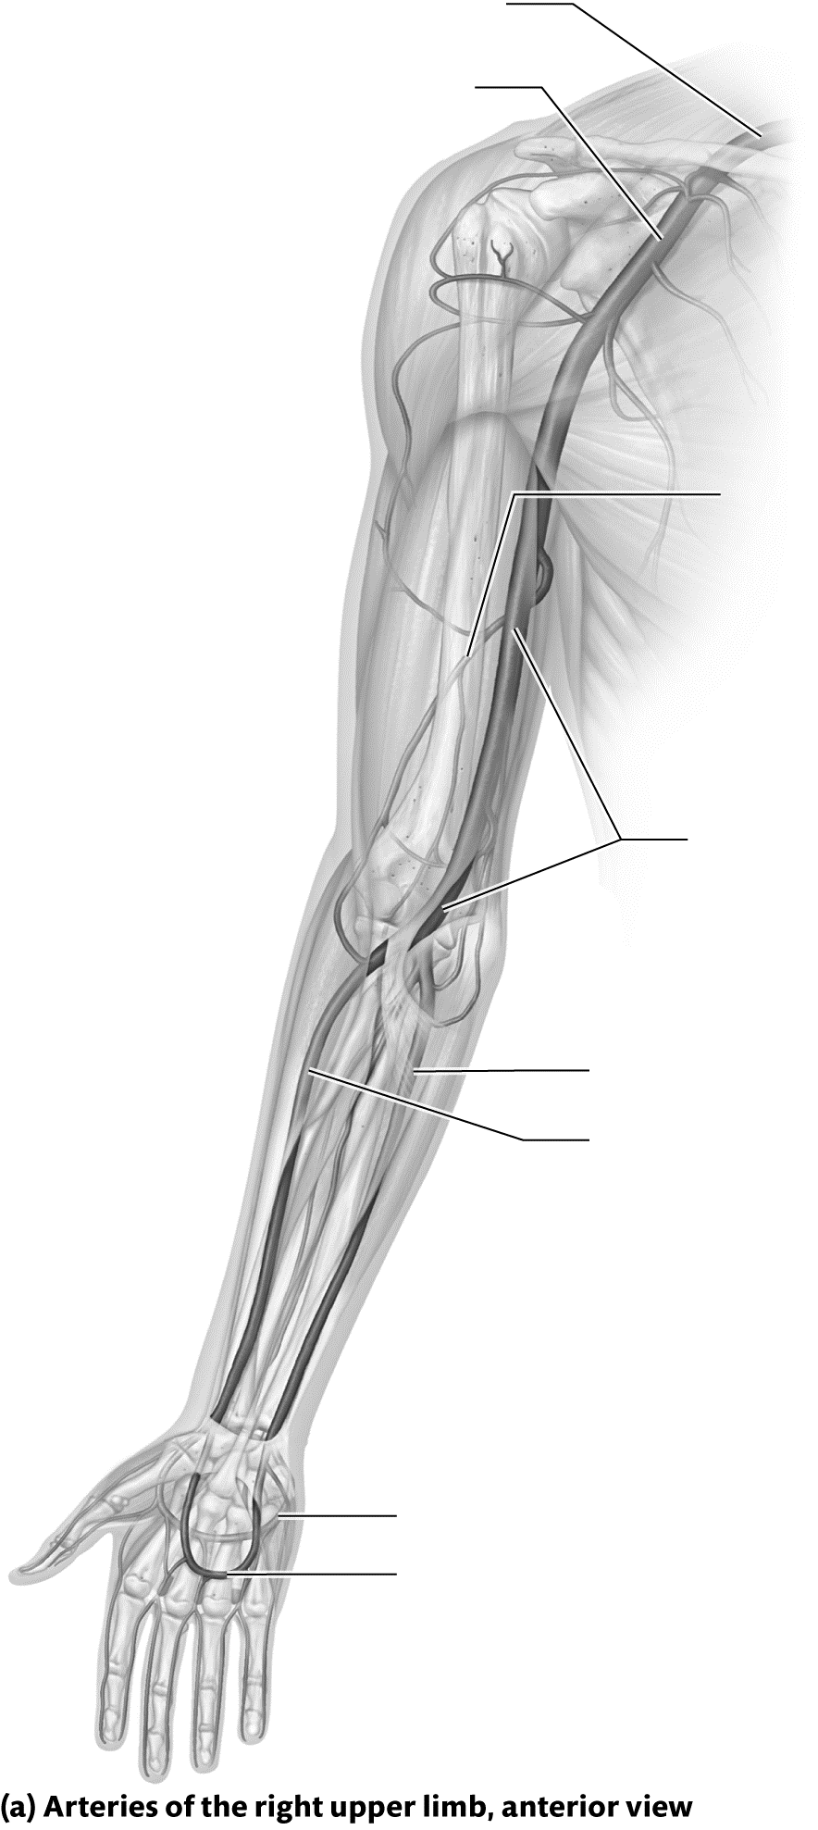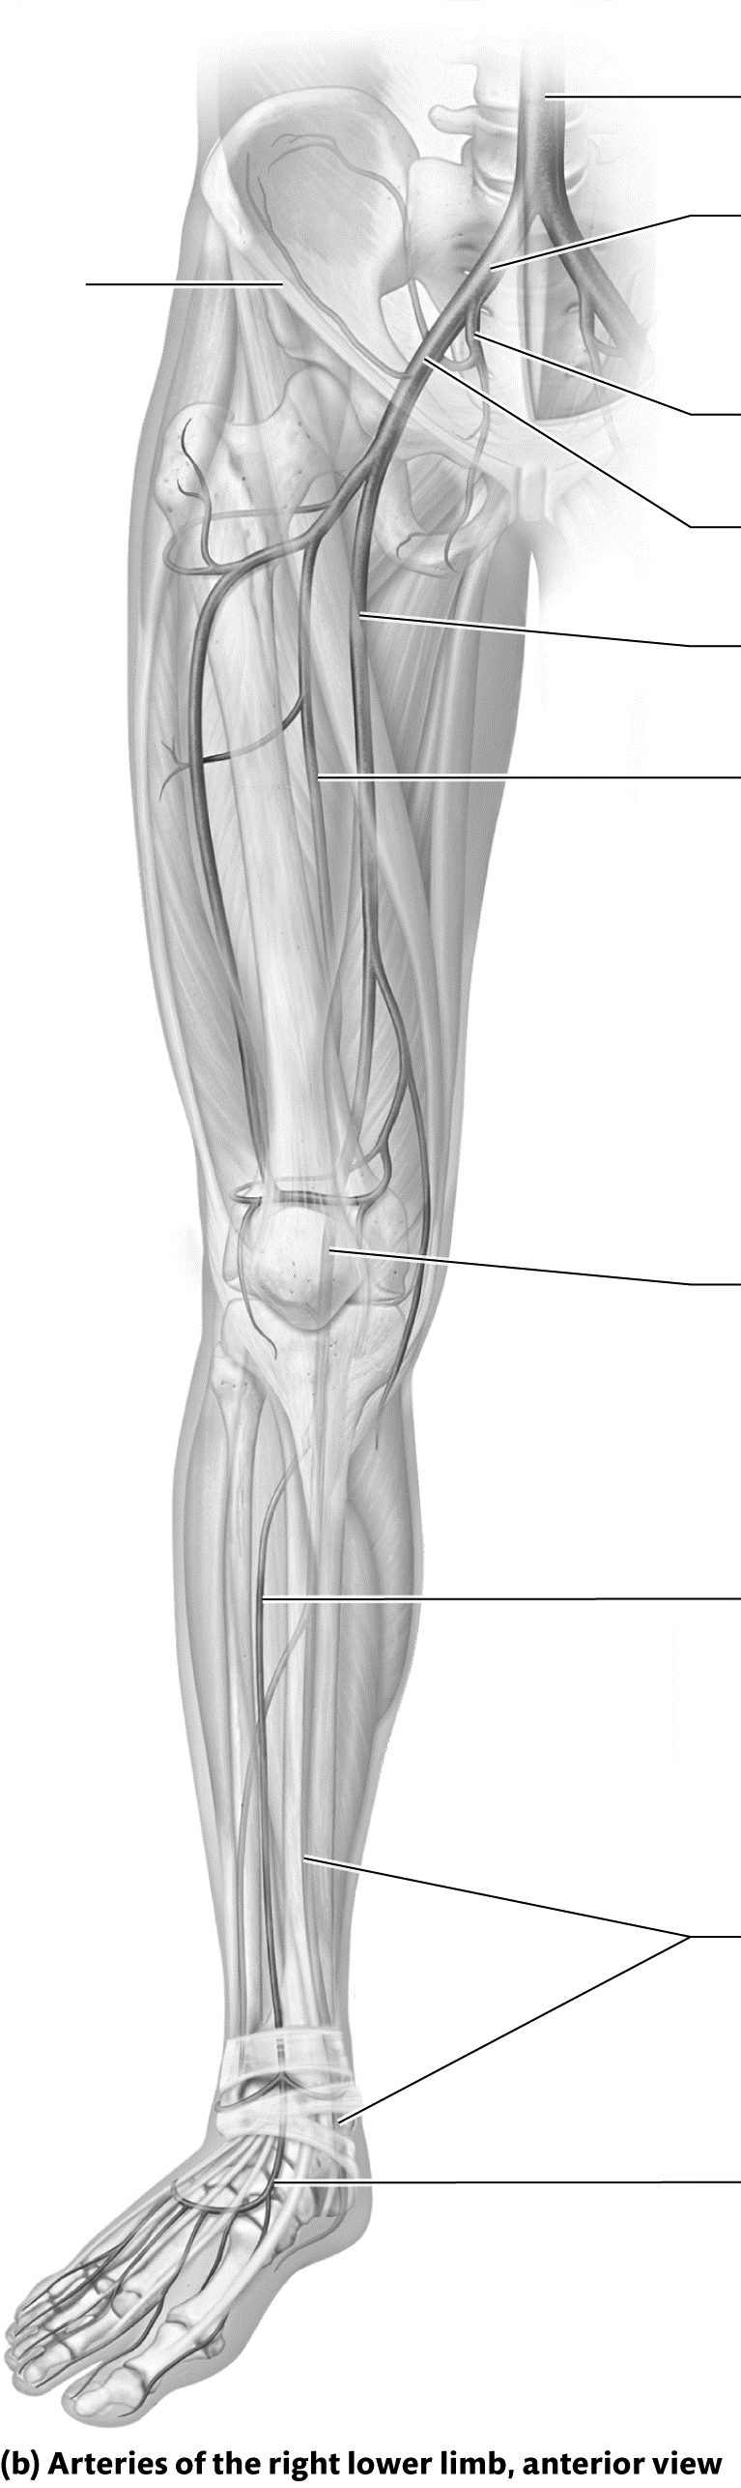
Identify It: Arteries of the Upper and Lower Limbs
Identify and color-code each of the arteries of the upper and lower limbs in Figure 18.7. Then, list the main structures that each artery supplies.

Figure 18.7 Arteries of the upper and lower limbs.
Identify It: Pulse Points
Identify and color-code each of the pulse points in Figure 18.8.
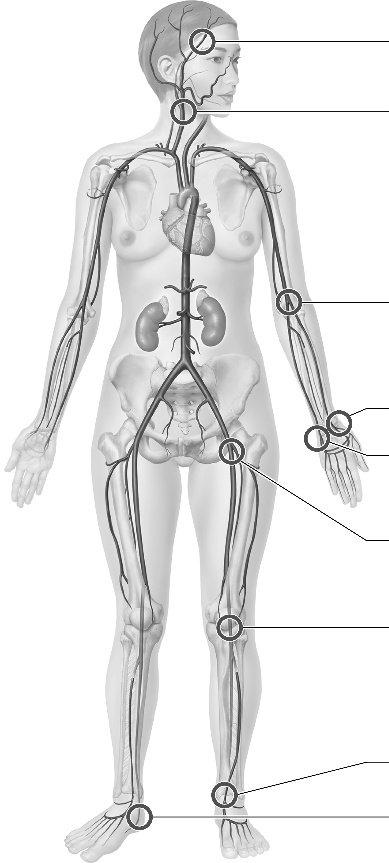

Figure 18.8 Common pulse points.
Key Concept: Why do arteries pulsate?


Mix It Up: Bring It Back by Predicting the Factors That Influence Blood Pressure
Let’s Mix It Up by predicting whether blood pressure will increase or decrease given each of the following conditions. Justify each of your responses.
• A person is having a severe allergic reaction and a systemic release of histamine is causing massive vasodilation.

• The person who was having an allergic reaction is given an injection of epinephrine.

• A person takes a diuretic that blocks the retention of water from the kidneys.

• A patient is administered a beta blocker, which blocks the effects of epinephrine and norepinephrine on the heart.

• A person takes excess erythropoietin, which abnormally increases the number of erythrocytes in the blood.

• A patient has a tumor that secretes excess amounts of ADH.

Module 18.7: Anatomy of the Systemic Veins
Module 18.7 in your text discusses the anatomy of the systemic veins. By the end of the module, you should be able to do the following:
1. Describe the patterns of venous blood drainage for the head and neck, the thoracic cavity, the abdominopelvic cavity, and the upper and lower limbs.
2. Identify major veins of the systemic circuit.
3. Describe the structure and function of the hepatic portal system.

Build Your Own Glossary
Following is a table listing key terms from Module 18.7. Before you read the module, use the glossary at the back of your book or look through the module to define the following terms.
Key Terms for Module 18.7
Term | Definition
Superior vena cava
Brachiocephalic vein
Common iliac vein
Inferior vena cava
Dural sinuses
Azygos system
Hepatic portal system
Outline It: Note Taking
Outline Module 18.7 using the note-taking technique you practiced in the introductory chapter (see Chapter 1). (The template is available in the study area of Mastering A&P.)

Identify It: Venous Drainage of the Head and Neck
Identify and color-code each of the veins of the head and neck in Figure 18.9. Then, list the main structures that each vein drains.
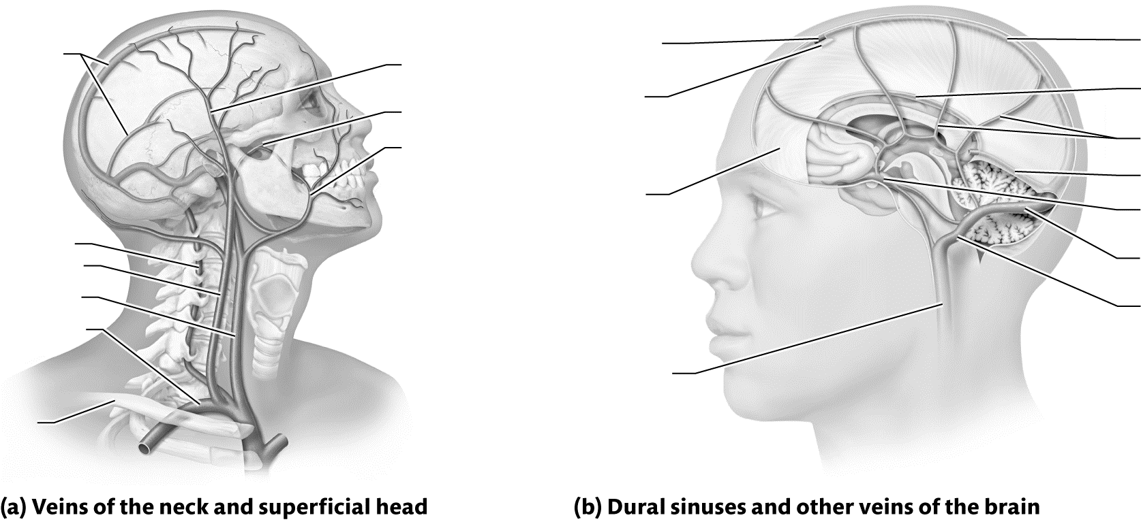
Figure 18.9 Venous drainage of the head and neck.
Key Concept: How is the venous drainage of the brain different from other structures in the body?

Identify It: Venous Drainage of the Thorax and Abdomen
Identify and color-code each of the veins of the thorax and abdomen in Figure 18.10. Then, list the main structures that each vein drains.
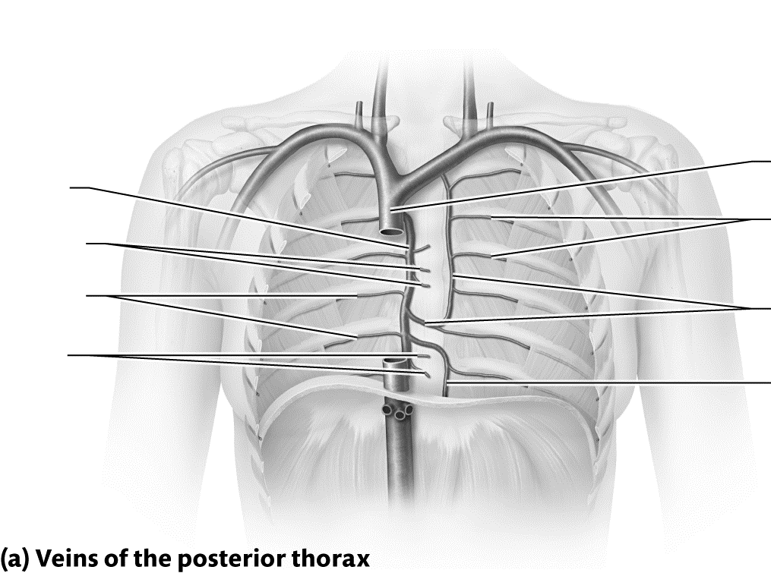

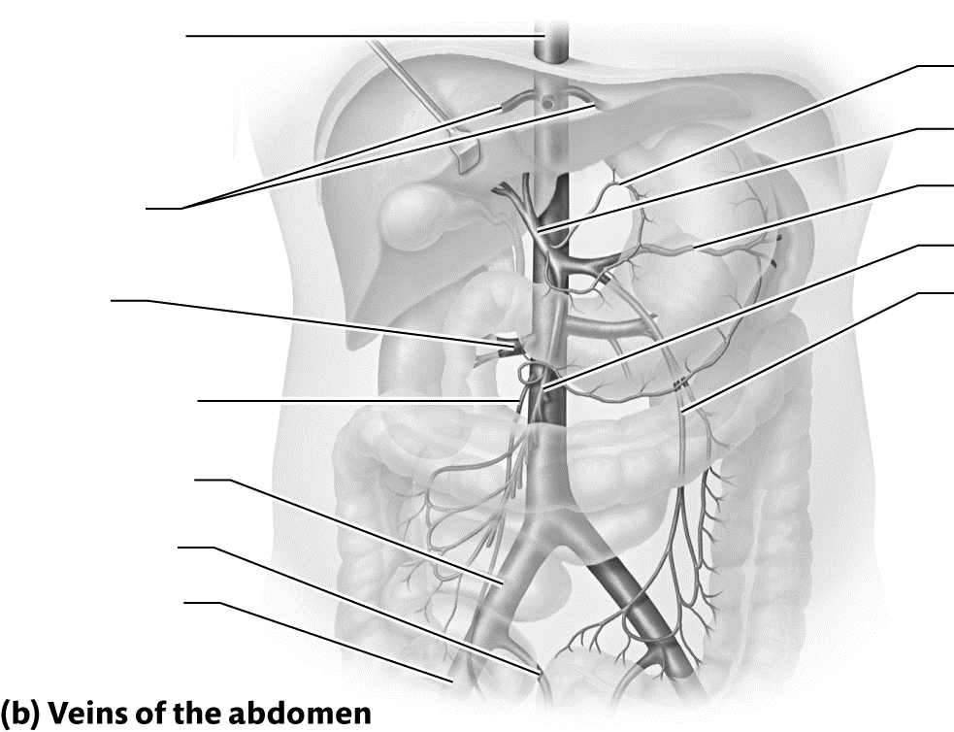

Figure 18.10 Venous drainage of the thorax and abdomen.
Key Concept: Where does the blood from most of the abdominal organs go before it enters the inferior vena cava? Why?

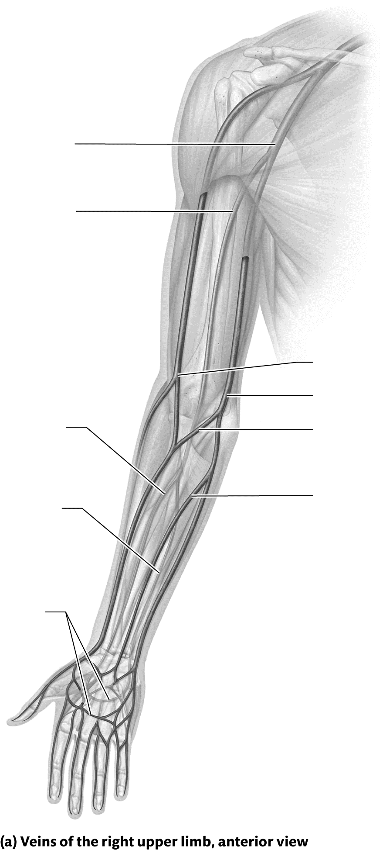
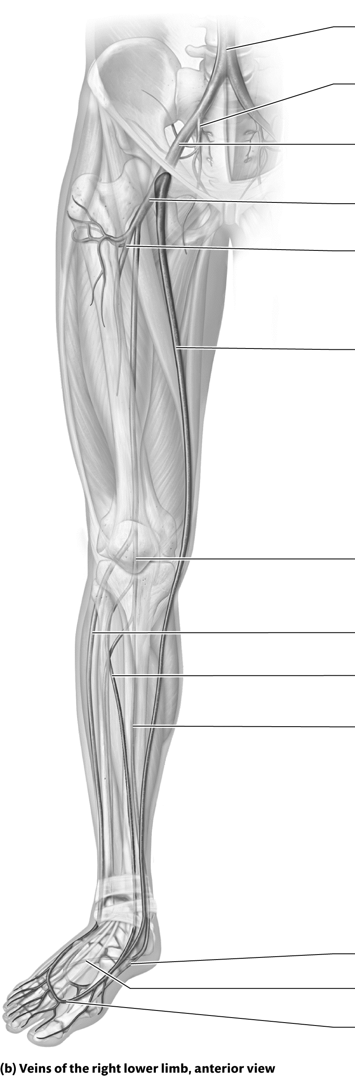
Identify It: Venous Drainage of the Upper and Lower Limbs
Identify and color-code each of the veins of the upper and lower limbs in Figure 18.11. Then, list the main structures that each vein drains.

Figure 18.11 Venous drainage of the upper and lower limbs.

Module 18.8: Putting It All Together: The Big Picture of Blood Vessel Anatomy
Module 18.8 gives you a larger view of the vessels by showing you the arteries and veins in context with other body structures. By the end of the module, you should be able to do the following:
1. Describe the general pathway of blood flow through the body.
2. Identify the arteries and veins of the body.

Identify It: Blood Vessels of the Head and Neck
Identify the arteries and veins of the head and neck in Figure 18.12.
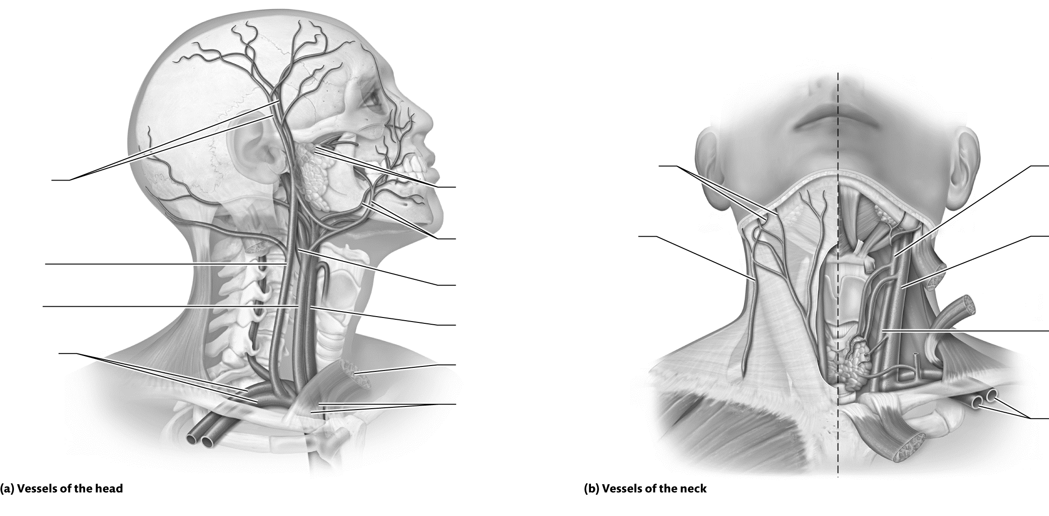

Figure 18.12 Blood vessels of the head and neck.
Identify It: Blood Vessels of the Abdomen
Identify the arteries and veins of the abdomen in Figure 18.13.
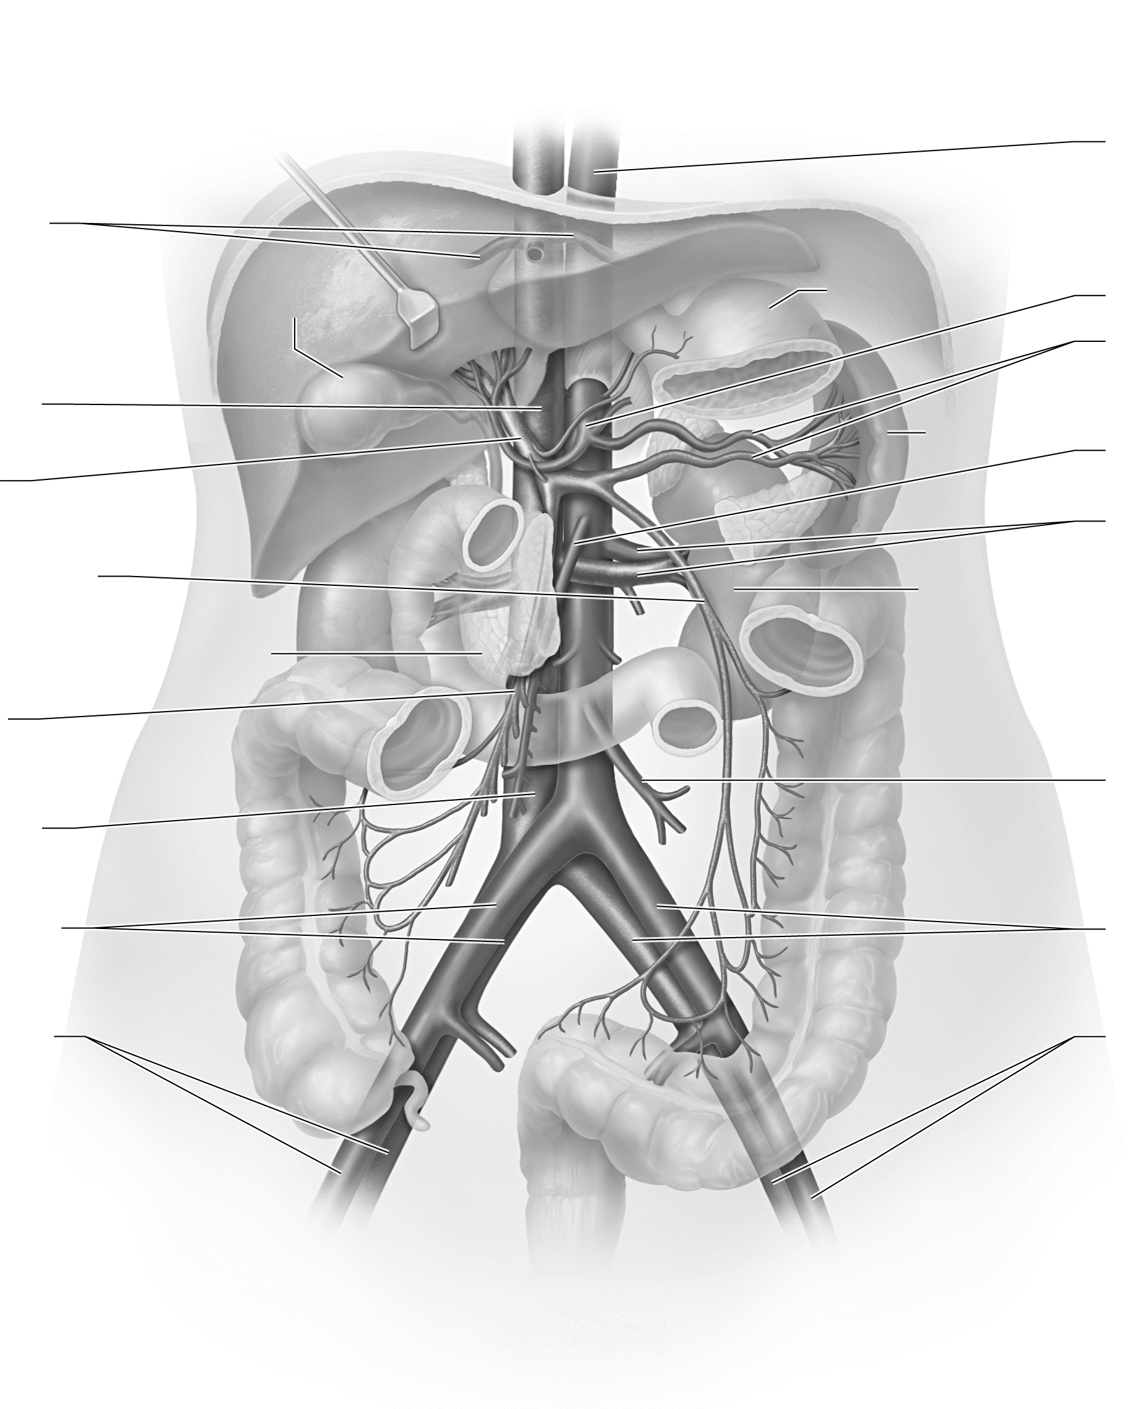

Figure 18.13 Blood vessels of the abdomen.
Identify It: Blood Vessels of the Upper and Lower Limbs
Identify the arteries and veins of the upper and lower limbs in Figure 18.14.
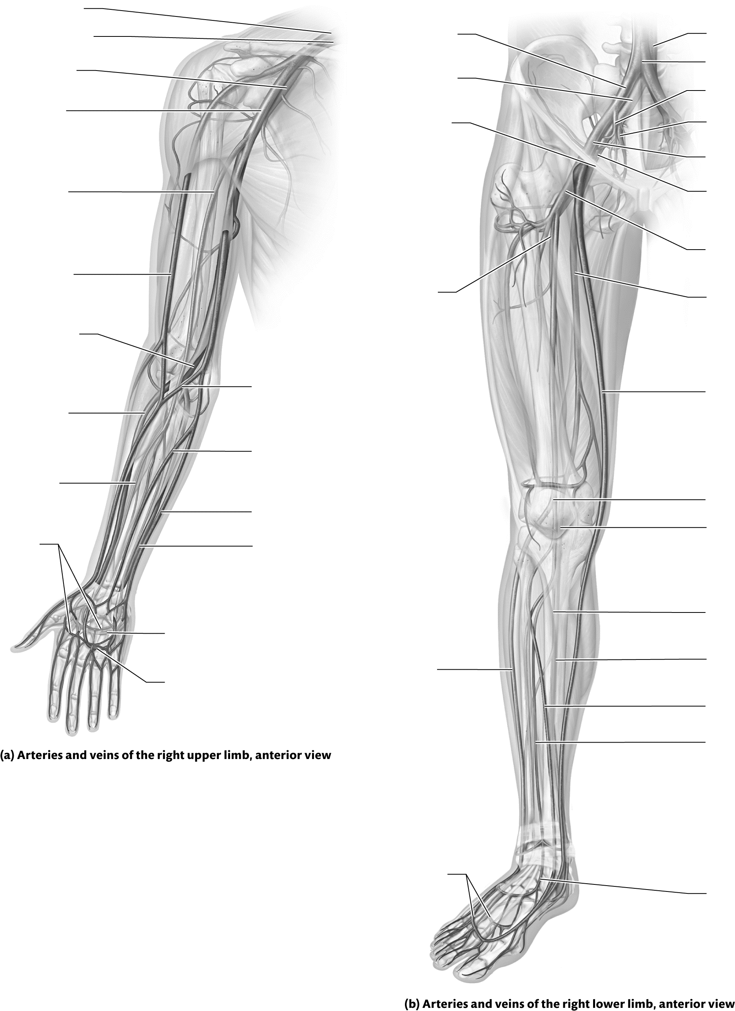

Figure 18.14 Blood vessels of the upper and lower limbs.

What Do You Know Now?
Let’s now revisit the questions you answered at the beginning of this chapter. How have your answers changed now that you’ve worked through the material?
• What effect does the sympathetic nervous system have on blood pressure?

• What are systole and diastole?

• Why can a person lose consciousness when placed in a choke hold?

Next Steps
You’ve just actively read your chapter, so now it’s time to start your Bring It Back practice sessions. What types of Bring It Back practice will you use to study the anatomy of the blood vessels? What types will you use to study the physiology of circulation?
__________________________________________________________________________________________
__________________________________________________________________________________________

The material in this chapter ties in closely with that of the heart chapter. How can you take advantage of this during your Bring It Back practice and Mix It Up?
__________________________________________________________________________________________
__________________________________________________________________________________________
How much time have you been studying A&P per day? How should you adjust this to best meet your study needs?
________________________________________________________________________________________________
________________________________________________________________________________

We’ll see you in the next chapter!

