17 | The Cardiovascular System I:  The Heart
What Do You Think You Already Know?
Try to answer the following questions before proceeding to the next section. If you’re unsure of the correct answers, give it your best attempt based on previous courses, previous chapters, or just your general knowledge.
• What is/are the function(s) of the heart?

• How are the two sides of the heart different?

• Do arteries carry oxygenated or deoxygenated blood? What about veins?

Module 17.1: Overview of the Heart
Module 17.1 in your text introduces you to the basic structure, location, and functions of the heart. By the end of the module, you should be able to do the following:
1. Describe the position of the heart in the thoracic cavity.
2. Describe the basic surface anatomy of the chambers of the heart.
3. Explain how the heart functions as a double pump and why this is significant.
Build Your Own Glossary
Following is a table listing key terms from Module 17.1. Before you read the module, use the glossary at the back of your book or look through the module to define the following terms.
Key Terms for Module 17.1
Term | Definition
Atria
Ventricles
Atrioventricular sulcus
Arteries
Veins
Pulmonary circuit
Capillaries
Systemic circuit
Outline It: Note Taking
Outline Module 17.1 using the note-taking technique you practiced in the introductory chapter (see Chapter 1). (The template is available in the study area of Mastering A&P.)

Identify It: Basic Anatomy of the Heart
Identify and color-code the structures in Figure 17.1. Also, identify which side of the heart is the pulmonary pump and which side is the systemic pump.
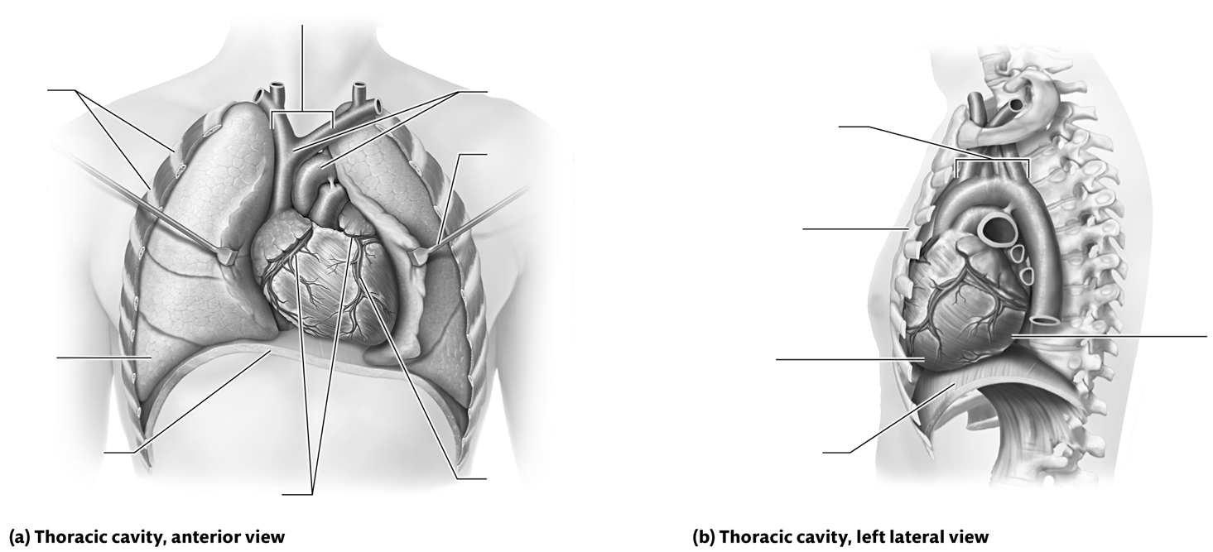
Figure 17.1 Basic anatomy of the heart.

Key Concept: What are the key differences between the right side and left side of the heart?

Describe It: The Pulmonary and Systemic Circuits
Write out the steps of blood flow through the pulmonary and systemic circuits in Figure 17.2. In addition, label and color-code the blood in the vessels and heart to indicate if it is oxygenated (red) or deoxygenated (blue).

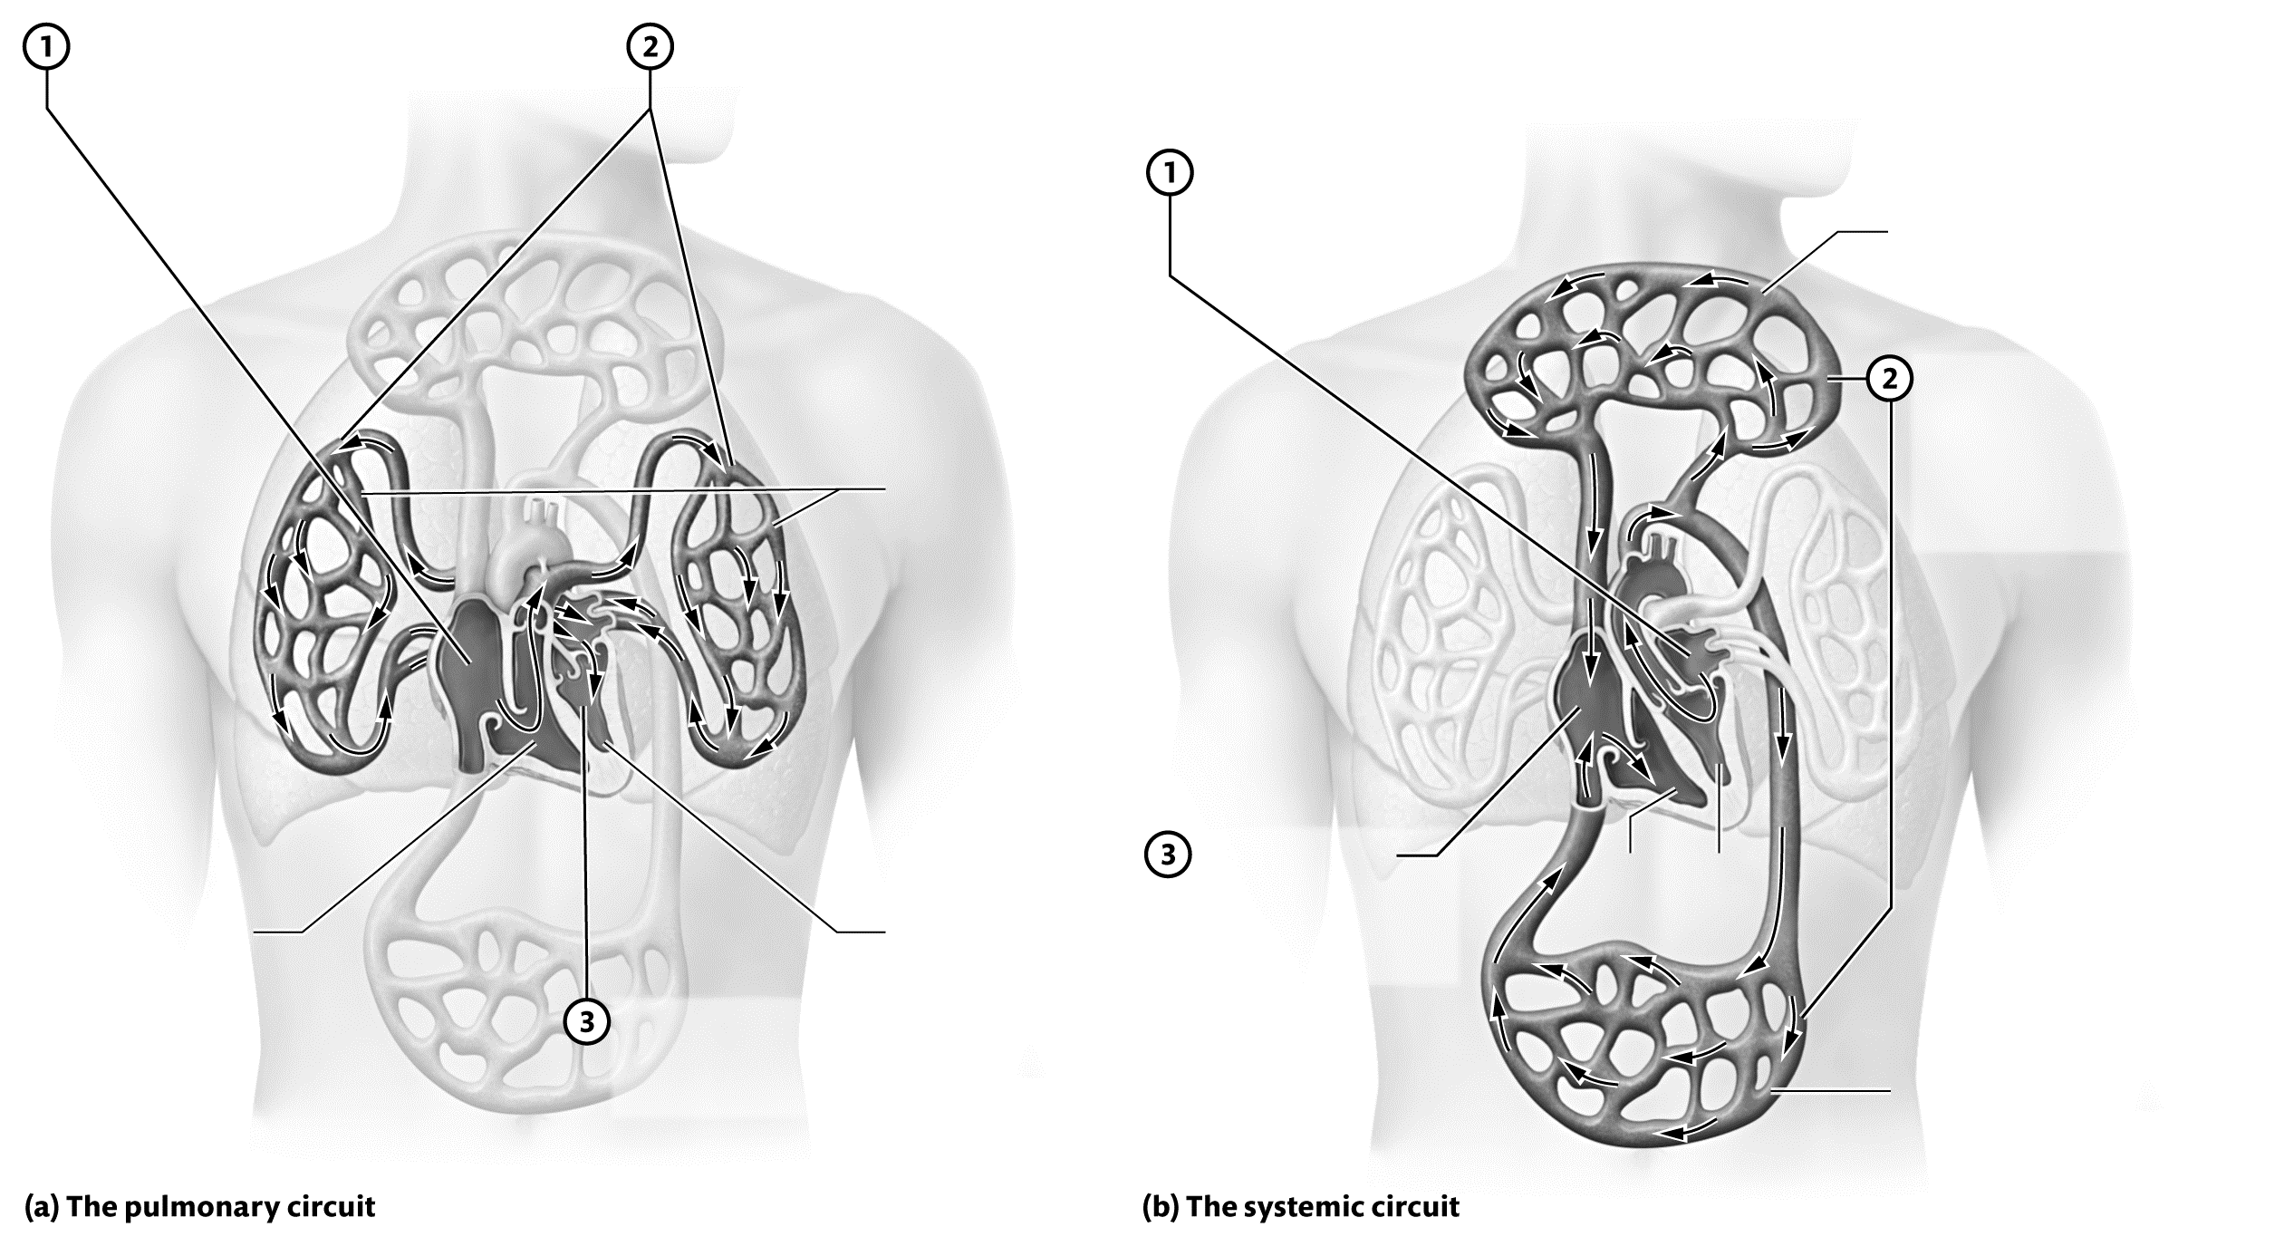

Figure 17.2 The pulmonary and systemic circuits.

Module 17.2: Heart Anatomy and Blood Flow Pathway
Now we look more closely at the anatomy of the heart and the pathway that blood takes as it passes through the heart. When you finish this module, you should be able to do the following:
1. Describe the layers of the pericardium and heart wall.
2. Describe the location and function of the coronary circulation and great vessels.
3. Describe the structure and function of the chambers, septa, valves, and other structural features of the heart.
4. Trace the pathway of blood flow through the heart, and explain how structures of the heart ensure that blood flows in a single direction.

Build Your Own Glossary
Following is a table listing key terms from Module 17.2. Before you read the module, use the glossary at the back of your book or look through the module to define the following terms.

Key Terms for Module 17.2
Term | Definition
Fibrous pericardium
Serous pericardium
Pericardial cavity
Myocardium
Endocardium
Coronary arteries
Coronary veins
Great vessels
Papillary muscles
Atrioventricular valves
Chordae tendineae
Semilunar valves
Outline It: Note Taking
Outline Module 17.2 using the note-taking technique you practiced in the introductory chapter (see Chapter 1). (The template is available in the study area of Mastering A&P.)

Identify It: The Pericardium and Layers of the Heart Wall
Identify and color-code the structures in Figure 17.3. Also, describe the functions of each structure that you label.
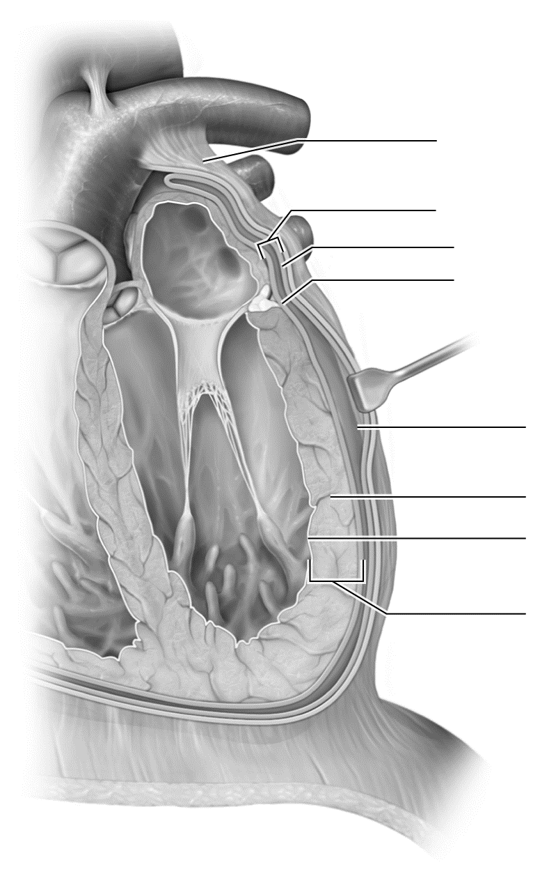

Figure 17.3 The pericardium and layers of the heart wall.
Key Concept: How does the serous pericardium envelop the heart? What is its function?

Build Your Own Summary Table: Coronary Vessels
As you read Module 17.2, build your own summary table about the coronary vessels by filling in the information in the following table.
Summary of the Hypothalamic and Anterior Pituitary Hormones
Vessel | Location | Area Supplied or Drained
Coronary Arteries
Right coronary artery
Marginal artery
Posterior interventricular artery
Left coronary artery
Anterior interventricular artery
Circumflex artery
Coronary Veins
Great cardiac vein
Middle cardiac vein
Small cardiac vein
Coronary sinus
Key Concept: What happens when blood flow through one or more of the coronary arteries is blocked? What can cause blockage of coronary arteries?

Identify It: Anatomy of the Heart
Identify and color-code the structures of the heart in Figure 17.4.
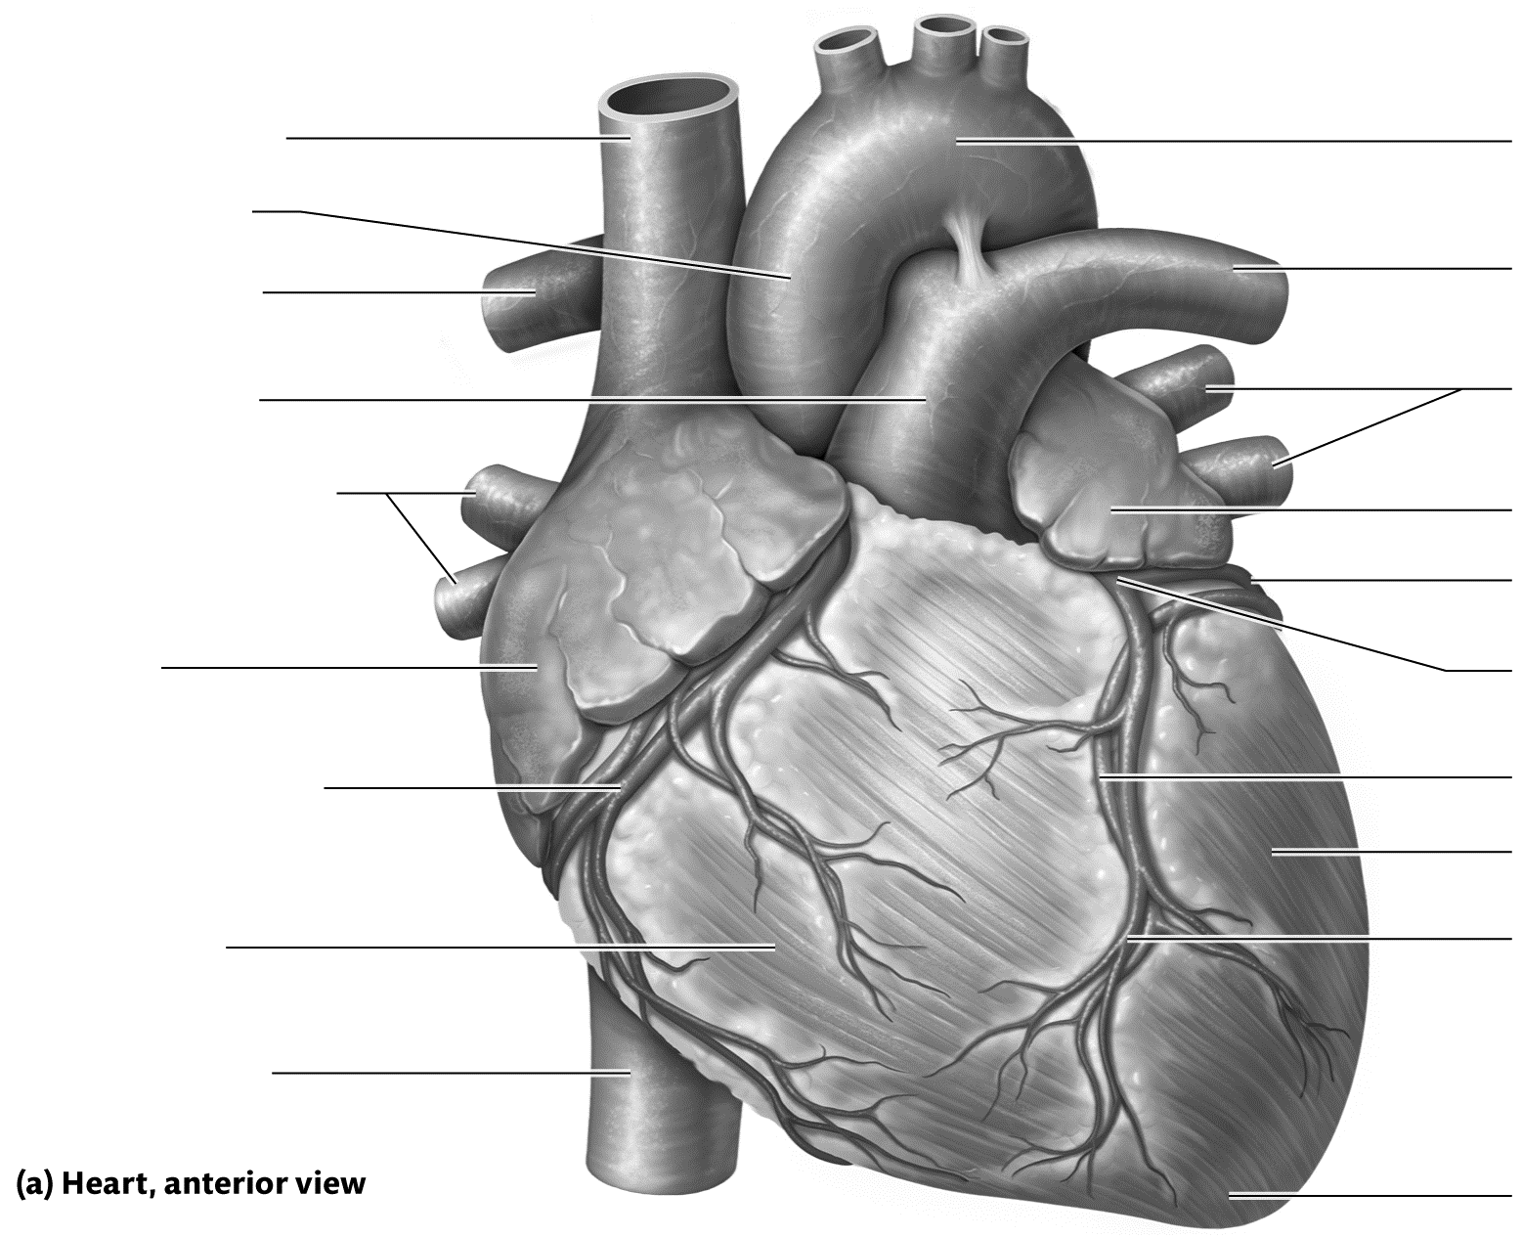

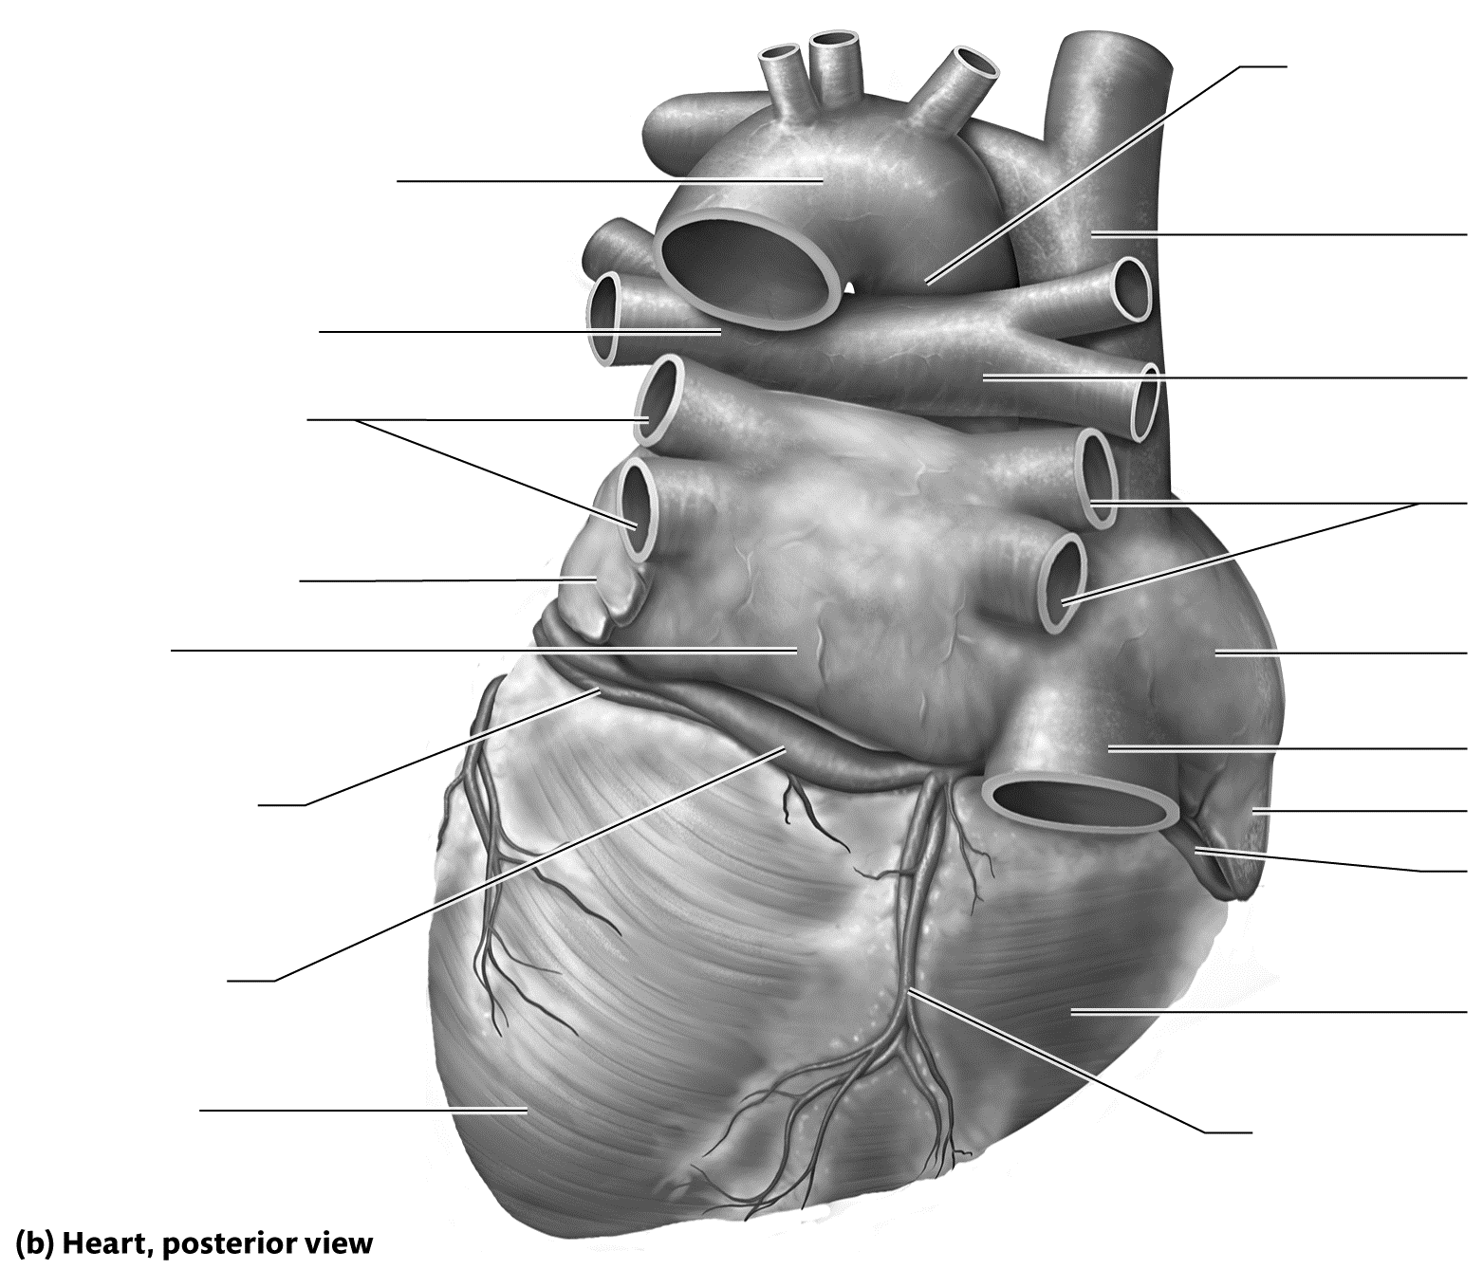

Figure 17.4 The heart.
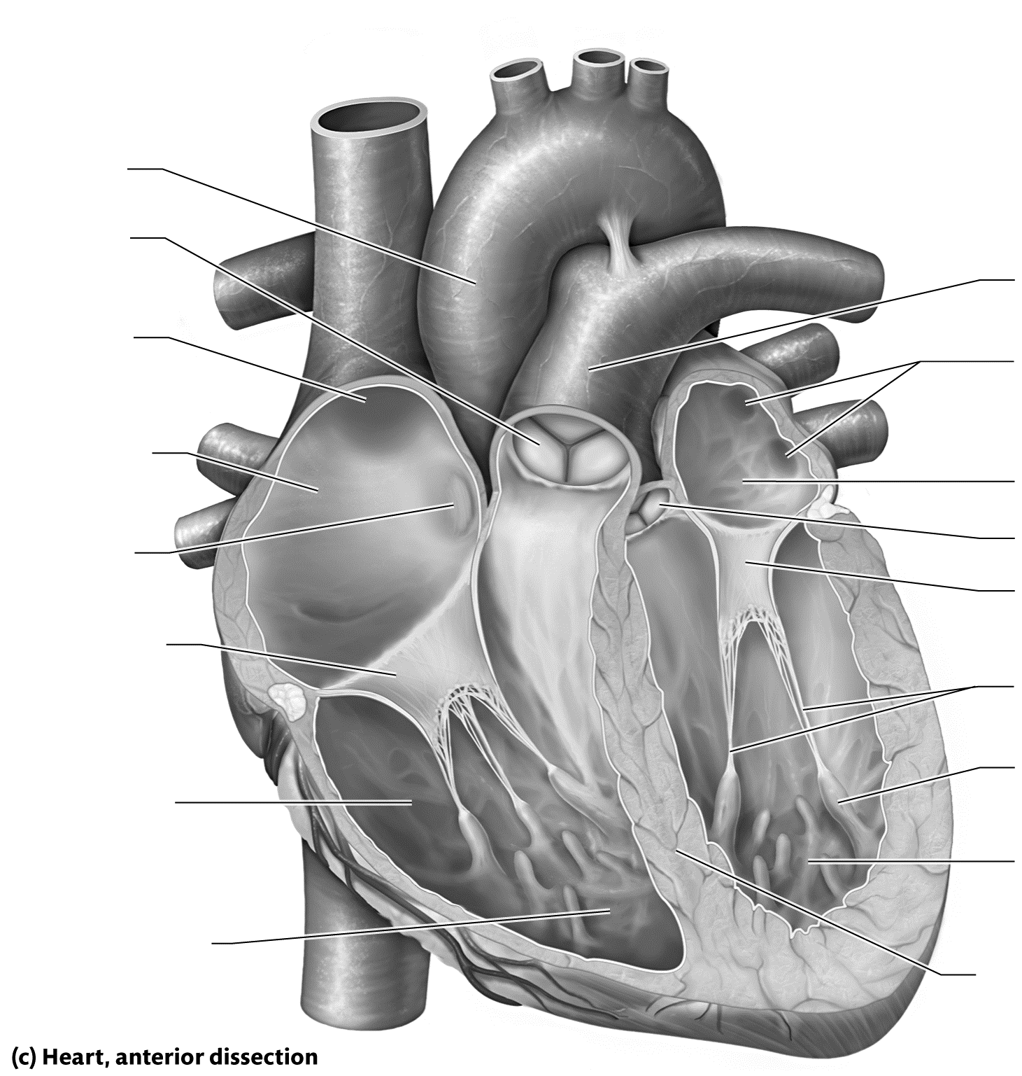

Figure 17.4 (continued)
Key Concept: How is the right side of the heart different structurally from the left side? Why?

Key Concept: Why is it important to prevent backflow of blood in the heart? Which structures prevent backflow, and how do they function?

Module 17.3: Cardiac Muscle Tissue Anatomy and Electrophysiology
This module explores the structure and function of the cardiac muscle tissue and examines its functional properties by visiting a familiar concept: electrophysiology. When you complete this module, you should be able to do the following:
1. Describe the histology of cardiac muscle tissue, and differentiate it from that of skeletal muscle.
2. Describe the phases of the cardiac muscle action potential, including the ion movements that occur in each phase, and explain the importance of the plateau phase.
3. Contrast the way action potentials are generated in cardiac pacemaker cells, cardiac contractile cells, and skeletal muscle cells.
4. Describe the parts of the cardiac conduction system, and explain how the system functions.
5. Identify the waveforms in a normal electrocardiogram (ECG), and relate the ECG waveforms to electrical activity in the heart.
Build Your Own Glossary
Following is a table listing key terms from Module 17.3. Before you read the module, use the glossary at the back of your book or look through the module to define the following terms.
Key Terms of Module 17.3
Term | Definition
Pacemaker cell
Contractile cells
Autorhythmicity
Intercalated discs
Plateau phase
Cardiac conduction system
Pacemaker potential
Sinoatrial node
Atrioventricular node
Purkinje fiber system
Sinus rhythm
Electrocardiogram

Outline It: Note Taking
Outline Module 17.3 using the note-taking technique you practiced in the introductory chapter (see Chapter 1). (The template is available in the study area of Mastering A&P.)

Key Concept: Why can the heart continue beating even when the brain has ceased most of its functions?

Key Concept: What is the importance of the intercalated discs to heart function? Why do skeletal muscle fibers lack intercalated discs?

Draw It: Cardiac Action Potentials
Draw two graphs: one of a contractile cell cardiac action potential and one of a pacemaker cell action potential. Label each part of the graph and indicate the ion channels that are opening or closing and the ions that are moving in or out of the cell. Then, study your graphs, and make a list of the key differences between the action potentials in the two cell types.
Contractile cell action potential: Pacemaker cell action potential:
Key differences:

Key Concept: What causes the plateau phase of the contractile cardiac cell action potential? Why is the plateau phase so important to the electrophysiology of the heart?

Identify It: The Cardiac Conduction System
Identify and color-code the structures of the cardiac conduction system in Figure 17.5. Then, trace the spread of the action potential starting from the sinoatrial node and ending with the ventricular contractile cells.

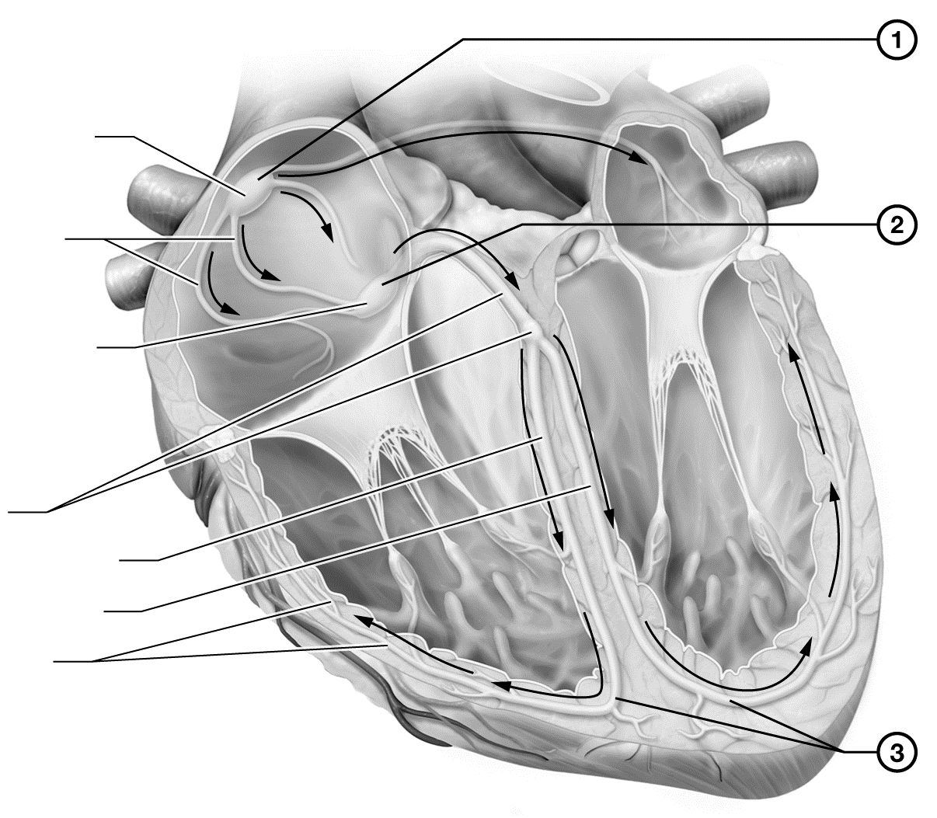

Figure 17.5 The cardiac conduction system.
Key Concept: Why is there a delay at the AV node? What would happen if the delay were too short? What would happen if it were too long?

Identify It and Describe It: The Electrocardiogram
Identify each wave and interval on the ECG in Figure 17.6. Then, draw the wave or interval in the following table and describe what it represents on the ECG.
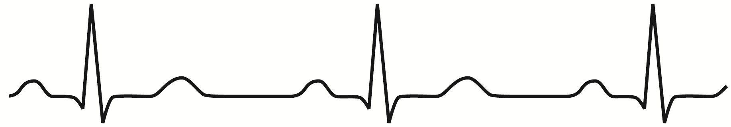

Figure 17.6 The electrocardiogram.

Waves and Intervals of the ECG
Portion of the ECG | Drawing | Definition/Meaning
P wave
QRS complex
T wave
R-R interval
P-R interval
Q-T interval
S-T segment
Key Concept: What part of the heart has an anomaly if the P wave is abnormal on an ECG? Explain.

Module 17.4: Mechanical Physiology of the Heart: The Cardiac Cycle
We now examine the other facet of cardiac physiology: mechanical physiology, or the actual pumping of the heart. At the end of this module, you should be able to do the following:
1. Describe the phases of the cardiac cycle.
2. Relate the opening and closing of specific heart valves in each phase of the cardiac cycle to pressure changes in the heart chambers.
3. Relate the heart sounds and ECG waveforms to the normal mechanical events of the cardiac cycle.
4. Compare and contrast pressure and volume changes of the left and right ventricles and the aorta during
one cardiac cycle.
Build Your Own Glossary
Following is a table listing key terms from Module 17.4. Before you read the module, use the glossary at the back of your book or look through the module to define the following terms.
Key Terms of Module 17.4
Term | Definition
Mechanical physiology
Heartbeat
Cardiac cycle
Heart sounds
Systole
Diastole
End-diastolic volume
End-systolic volume
Outline It: Note Taking
Outline Module 17.4 using the note-taking technique you practiced in the introductory chapter (see Chapter 1). (The template is available in the study area of Mastering A&P.)

Key Concept: How do pressure gradients drive blood flow through the heart? How do pressure gradients influence the functioning of the heart valves?

Describe It: Heart Sounds
Describe the location and timing of each heart sound in the following table.
Location and Timing of Heart Sounds
Area | Pulmonary | Tricuspid
Location of sound
Timing of sound

Area | Mitral | Aortic
Location of sound
Timing of sound

Describe It: The Cardiac Cycle
Write out the steps of the cardiac cycle in Figure 17.7. In addition, label and color-code all key components of the cycle, and be sure to color deoxygenated blood blue and oxygenated blood red.
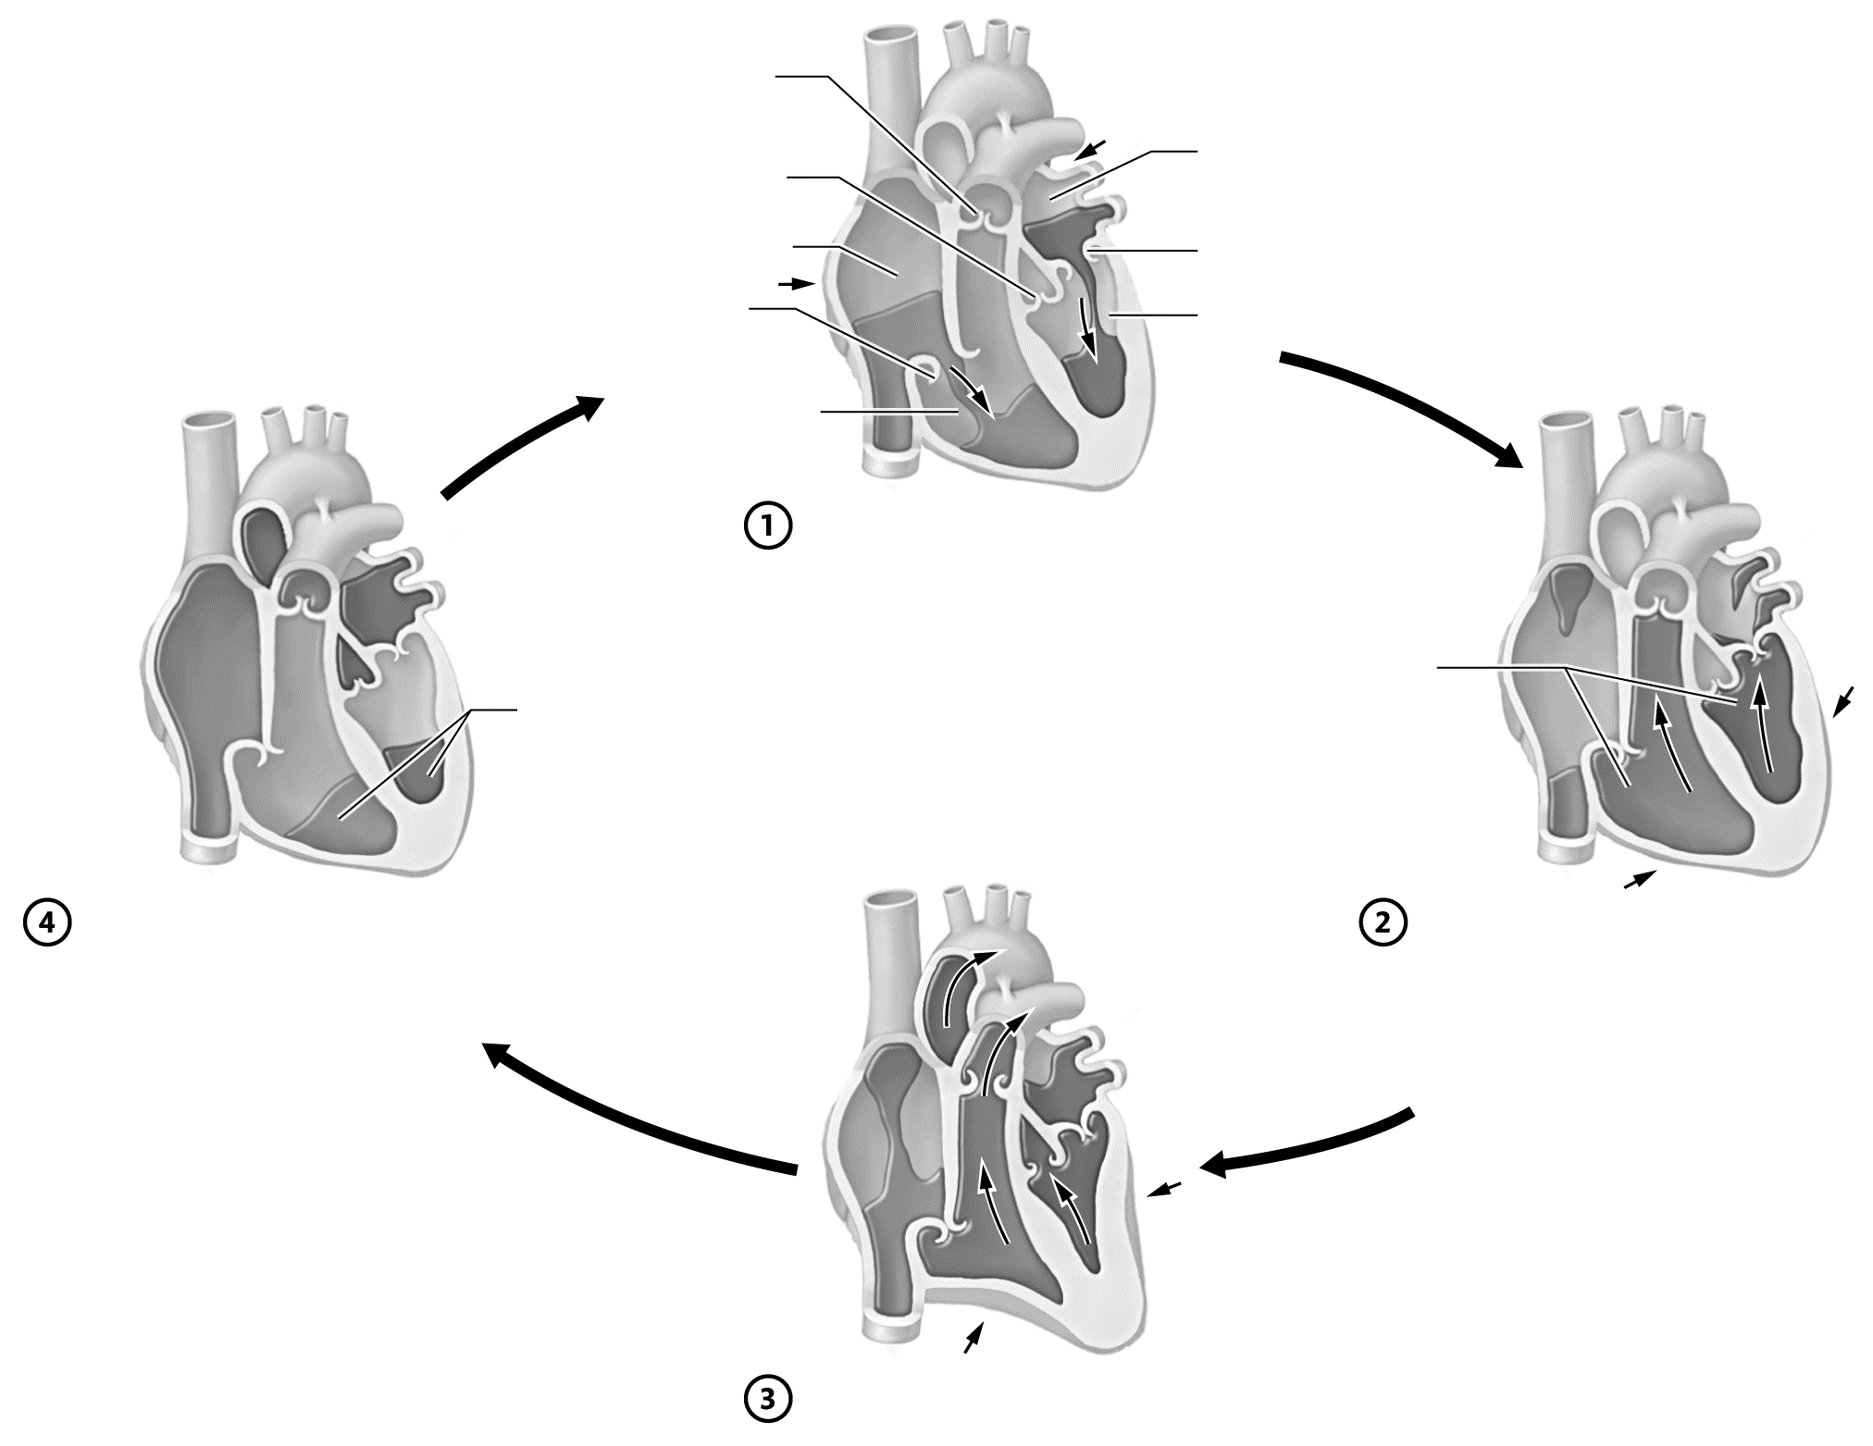
Figure 17.7 The cardiac cycle.

Key Concept: You notice that a patient has QRS waveforms on his ECG, indicating that his ventricles are undergoing electrical activity. Does this finding always mean that a heart is actually pumping blood? Explain.


Mix It Up: Bring It Back by Tracing the Pathway of Blood Flow through the Heart
Let’s Mix It Up by tracing the pathway of blood flow through the heart. In the space below, write out the overall pathway of blood flow through the heart, starting with the superior and inferior venae cavae and ending with the aorta. Be sure to include the valves and the pulmonary circulation and indicate where blood is oxygenated or deoxygenated.

Module 17.5: Cardiac Output and Regulation
This module looks at the amount of blood pumped by the heart and the factors that influence this value. At the end of this module, you should be able to do the following:
1. Define and calculate cardiac output, given stroke volume, heart rate, and end-diastolic and end-systolic volumes.
2. Describe the factors that influence preload, afterload, and contractility, and explain how they affect cardiac output.
3. Explain the significance of the Frank-Starling law for the heart.
4. Discuss the influence of positive and negative inotropic and chronotropic agents on stroke volume and heart rate, respectively.
5. Predict how changes in heart rate and/or stroke volume will affect cardiac output.

Build Your Own Glossary
Following is a table listing key terms from Module 17.5. Before you read the module, use the glossary at the back of your book or look through the module to define the following terms.

Key Terms of Module 17.5
Term | Definition
Heart rate
Stroke volume
Cardiac output
Preload
Frank-Starling law
Contractility
Afterload
Heart failure
Outline It: Note Taking
Outline Module 17.5 using the note-taking technique you practiced in the introductory chapter (see Chapter 1). (The template is available in the study area of Mastering A&P.)

Key Concept: If a person has a stroke volume of 55 ml and a heart rate of 80 beats per minute, what is his or her cardiac output? Is this a normal value? If not, how is it abnormal?

Complete It: Factors That Influence Stroke Volume
Fill in the blanks to complete the following paragraphs that describe the factors influencing stroke volume.
The ________________ refers to the amount a ventricular cell is stretched before contracting. Generally, as it increases, stroke volume also ________________ due to a phenomenon known as the ________________ ________________ ________________. This law states that cells contract ________________ when their sarcomeres are stretched prior to contraction. One of the major determinants of preload is ________________ ________________, or the amount of blood veins deliver to the heart. The heart’s ________________ is its inherent ability to pump. As this increases, the stroke volume also ________________ and the ________________ ________________ volume.
A final factor that influences stroke volume is ________________, which is the force against which the heart must pump. It is largely determined by the ________________ of the circuit. When afterload increases, stroke volume generally ________________ and ________________ ________________ volume ________________.
Key Concept: Does a high end-systolic volume (ESV) signify a high stroke volume or a low stroke volume? What could cause a high ESV, and what would this do to cardiac output?

Predict It: Effect of Cardiac Output
Following are several scenarios in which one or more variables that affect cardiac output are altered. Predict in each scenario which factor is affected (preload, contractility, or afterload) and whether cardiac output is likely to increase or decrease, and explain why.
• The heart muscle is damaged after a heart attack.

• A person is taking an angiotensin-receptor blocker, which causes vasodilation.

• A person is taking the medication digitalis, which increases the strength of the heart’s contraction.

• Venous return decreases due to significant edema.

• A person is running from an angry badger, and the sympathetic nervous system has activated in full force.

Key Concept: Why does left ventricular failure cause pulmonary congestion and edema? Why do both right ventricular failure and left ventricular failure cause peripheral edema?


What Do You Know Now?
Let’s now revisit the questions you answered at the beginning of this chapter. How have your answers changed now that you’ve worked through the material?
• What is/are the function(s) of the heart?

• How are the two sides of the heart different?

• Do arteries carry oxygenated or deoxygenated blood? What about veins?

Next Steps
You’ve just actively read your chapter, so now it’s time to start your Bring It Back practice sessions. What types of Bring It Back practice will you use to study the heart and cardiac physiology?
__________________________________________________________________________________________
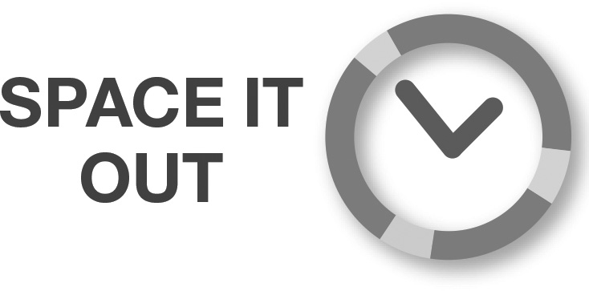
__________________________________________________________________________________________

If you’re at the start of a new term, map out a study schedule for yourself that allows you to Space It Out and Mix It Up.
__________________________________________________________________________________________
__________________________________________________________________________________________
This chapter likely marks the beginning of your A&P II course. How satisfied were you with how much you learned and your grade in A&P I? How will you adjust your study plans in A&P II to best meet your goals?
________________________________________________________________________________________________
________________________________________________________________________________

We’ll see you in the next chapter!

